

# D&T II

# D05: Hackathon

# **Performance test suite**

# Group 20

**Candelario Luna, Luis**

**Carrasco Márquez, Antonio**

**Gil Guerrero, Luis**

**Márquez Orellana, Francisco**

**Morales Moreno, Sergio**

**Moreno Ruiz, Juanma**

Content

Introduction: 6

Performance tests: 7

Use case 1: 7

As a not authenticated actor I want to register as a Representative 7

Analysis results: 9

Use case 2: 10

As a not authenticated actor I want to register as a manager. 10

Analysis results: 12

Use case 3: 13

As a not authenticated actor I want to register as a Race Director 13

Analysis results: 15

Use case 4: 16

As a not authenticated actor I want to register as a Rider 16

Analysis results: 18

Use case 5: 19

As a not authenticated actor I want to register as a Sponsor 19

Analysis results: 21

Use case 6: 22

As a not authenticated actor I want to list and display the circuits 22

Analysis results: 24

Use case 7: 25

As an administrator I want to create administrators account 25

Analysis results: 27

Use case 8: 28

As an authenticated actor I want to edit my personal data 28

Analysis results: 30

Use case 9: 31

As an admin I want to display a list of suspicious actors, ban or unban those actors. 31

Analysis results: 33

Use case 10: 34

As an authenticated user I want to list and display the riders and also list and display their social profiles 34

Analysis results: 36

Use case 11: 37

As an authenticated actor I want to send a message to others actors of the system. 37

Analysis results: 39

Use case 12: 40

As an authenticated user I want create new message boxes. 40

Analysis results: 42

Use case 13: 43

As an administrator I want to manage the categories of the system. 43

Analysis results: 45

Use case 14: 46

As an admin I want to broadcast a message to all of the actors of the system 46

Analysis results: 48

Use case 15: 49

As a rider I want to manage my victories on my palmares. 49

Analysis results: 51

Use case 16: 52

As a rider I want to manage my laps on my palmares. 52

Analysis results: 54

Use case 17: 55

As a rider I want to manage my podiums on my palmares. 55

Analysis results: 57

Use case 18: 58

As a rider I want to manage my poles on my palmares 58

Analysis results: 60

Use case 19: 61

As a rider I want to manage my podiums on my palmares 61

Analysis results: 63

Use case 20: 64

As a Race Director I want to manage my world championships 64

Analysis results: 66

Use case 21: 67

As a Race Director I want to manage my announcements 67

Analysis results: 69

Use case 22: 70

As a Race Director I want to manage the forecast of a grand prix 70

Analysis results: 73

Use case 23: 74

As a not authenticated actor I want to navigate to the world championship and their circuits and also navigate to the fan clubs of the riders. 74

Analysis results: 76

Use case 24: 77

As a Race Director I want to create and edit my grand prixes. 77

Analysis results: 79

Use case 25: 80

As a Race Director I want to list, display and delete my grand prixes. 80

Analysis results: 82

Use case 26: 83

As a team manager I want to manage my answers to the announcements 83

Analysis results: 85

Use case 27: 86

As an admin I want to manage the sectors of the circuits 86

Analysis results: 88

Use case 28: 89

As a representative I want to manage my fan clubs 89

Analysis results: 91

Use case 29: 92

As a Rider I want to use a finder to filter the grand-prixes and navigate to them. 92

Analysis results: 94

Use case 30: 95

As a race director I want to manage my applications and announcements 95

Analysis results: 97

Use case 31: 98

As a Race Director I want to create my circuits. 98

Analysis results: 100

Use case 32: 101

As a Race Director I want to list, display and delete my circuits 101

Analysis results: 103

Use case 33: 104

As a representative I want to manage my meetings. 104

Analysis results: 106

Use case 34: 107

As a team manager I want to manage my team. 107

Analysis results: 109

Use case 35: 110

As a team manager I want to sign riders to my team. 110

Analysis results: 112

Use case 36: 113

As a rider I want to see the world championships, grand prixes, circuits, races, forecasts and my team. 113

Analysis results: 115

Use case 37: 116

As a rider I want to manage my meetings. 116

Analysis results: 118

Use case 38: 119

As a sponsor I want to create sponsorships. 119

Analysis results: 121

Use case 39: 122

As a sponsor I want to see and update my sponsorships. 122

Analysis results: 124

Use case 40: 125

As an admin I want to launch a process to compute the score of every representative and rider, edit the list of the positive and negative words used to compute the score and display a dashboard with information of the system: 125

Analysis results: 127

Use case 41: 128

As a sponsor I want to see the teams of the systems. 128

Analysis results: 130

Use case 42: 131

As an authenticated user I want update and delete message boxes. 131

Analysis results: 133

Conclussion: 134

# Introduction:

To test all use cases for Acme-Motorsports we used Jmeter with the following method:

* Group some requisites to do the testing to be more efficient.
* Exclude the suggested URL patterns by Jmeter to do the header captures.
* Various test with a number between 200 and 300 users and 10 loops to see the maximum users that supports the system without any problem relative to the user experience, in this case we are going to check the time spend to do the actions looking at the 90% line results and the errors encountered during the test, if any.
* More than 3 seconds to complete an action is considered a failed test for than number of users.
* Analyze the most probable reason that made the error happen. Checking the computer performance we will observe the processor, memory, disk and network behavior.
* Not surpass 300 users and 10 loops due to the fact that the computer cannot handle this numbers of users, resulting in blue screens and shutdowns, please note that this is for the safety of the hardware.

All the test were made with the same computer in the pre-production virtual machine**, with 4 GB of ram and a 2 core processor.**

The computer specifications are:

* CPU: Intel core I5 7200u
* Mainboard: Medion D15KHN
* Memory: 8 GB DDR3
* Graphics: Nvidia Geforce GTX 950M
* 245 GB SSD

# Performance tests:

## Use case 1:

### As a not authenticated actor I want to register as a Representative

Number of Threads (users): 250

Ramp-Up Period (in seconds): 1

Loop count: 10

Performance test 90% results: Total 55ms.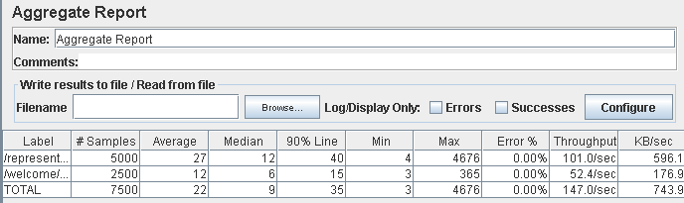

Performance thread results: 8,820 per minute 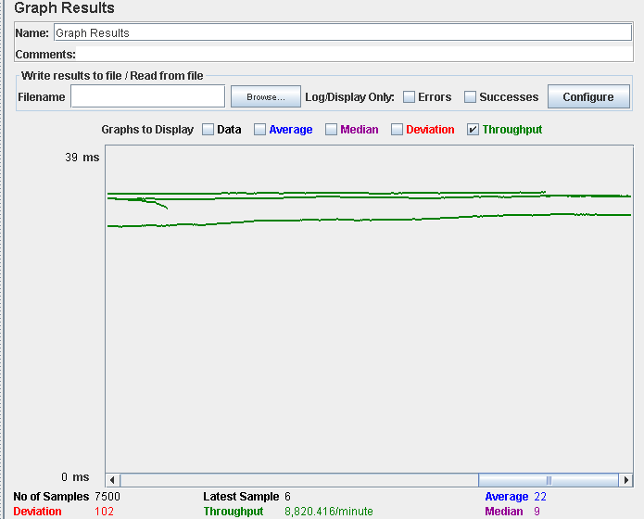

Number of Threads (users): 300

Ramp-Up Period (in seconds): 1

Loop count: 10

Performance test 90% results: Total 135ms.

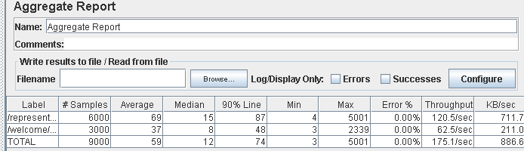

Performance thread results: 10,508 per minute

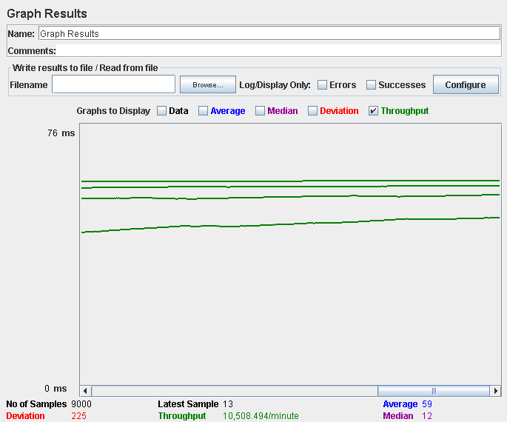

Computer performance:

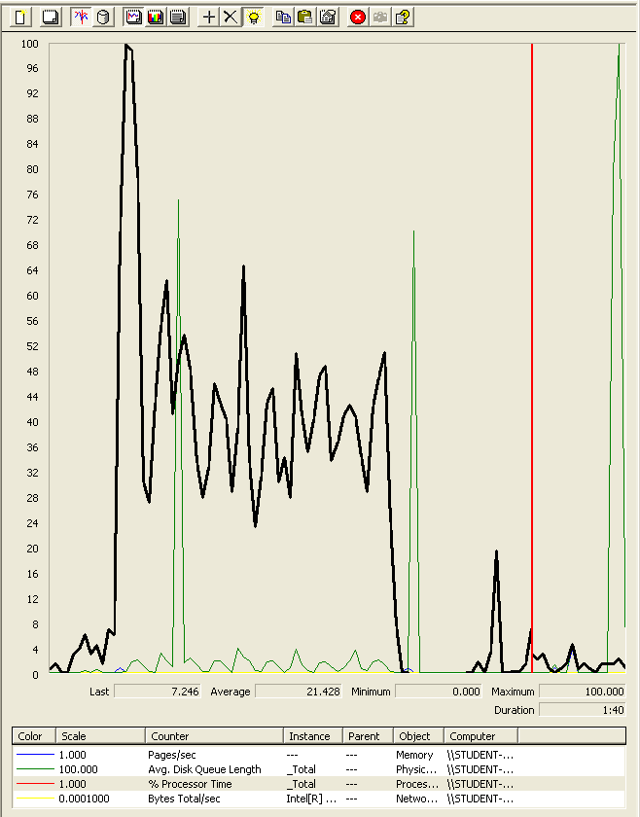

### Analysis results:

250 users and 10 loops: the application runs perfectly.

300 users and 10 loops: the application runs perfectly.

## Use case 2:

### As a not authenticated actor I want to register as a manager.

Number of Threads (users): 250

Ramp-Up Period (in seconds): 1

Loop count: 10

Performance test 90% results: Total 290ms.

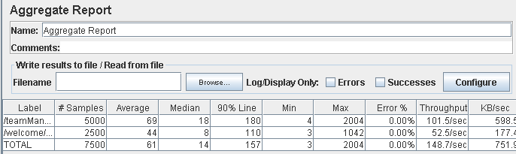

Performance thread results: 8,920 per minute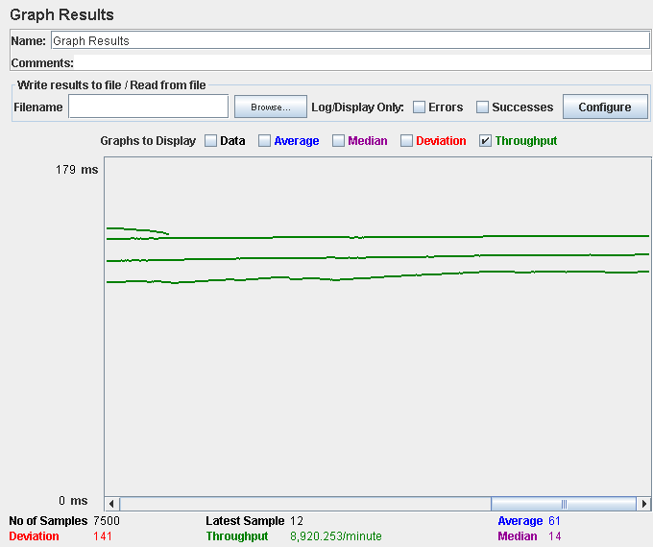

Number of Threads (users): 300

Ramp-Up Period (in seconds): 1

Loop count: 10

Performance test 90% results: Total 146ms.

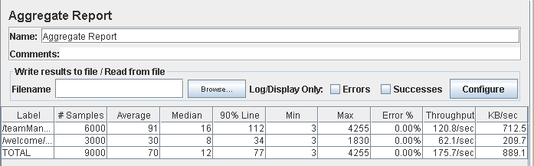

Performance thread results: 10,554 per minute

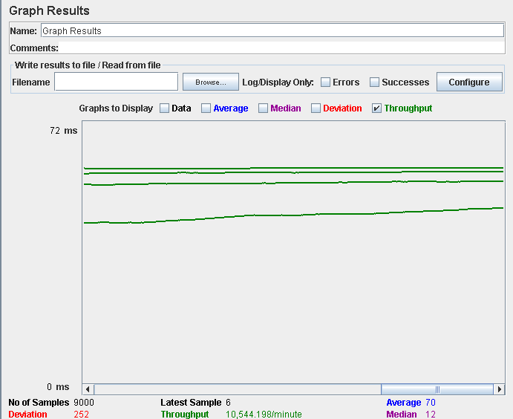

Computer performance:

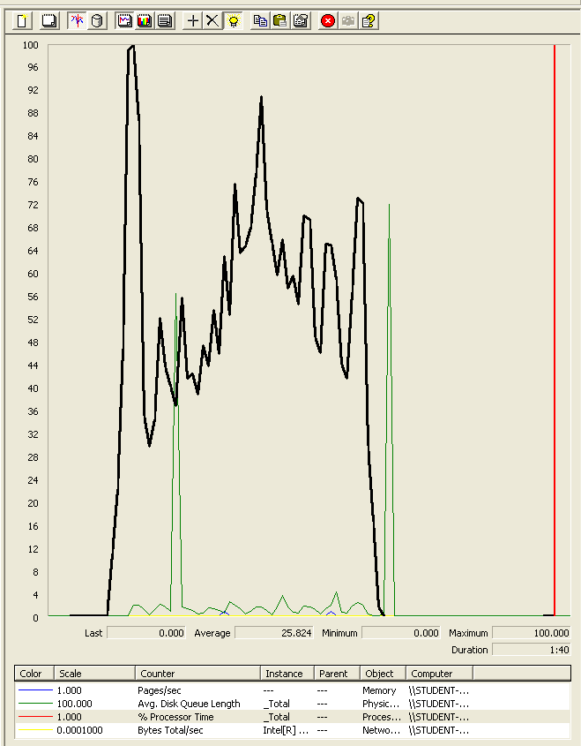

### Analysis results:

250 users and 10 loops: the application runs perfectly.

300 users and 10 loops: the application runs perfectly.

## Use case 3:

### As a not authenticated actor I want to register as a Race Director

Number of Threads (users): 250

Ramp-Up Period (in seconds): 1

Loop count: 10

Performance test 90% results: Total 100ms.

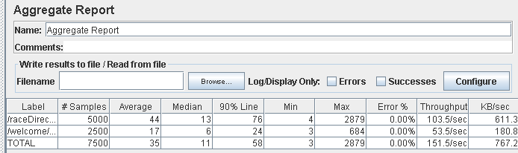

Performance thread results: 9,902 per minute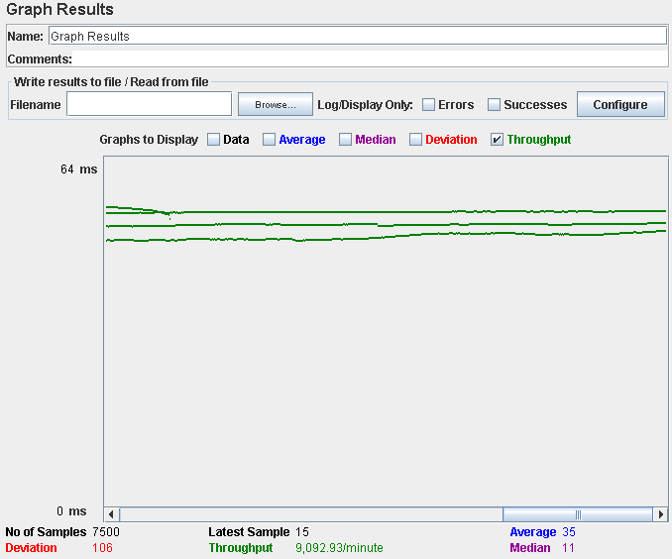

Number of Threads (users): 300

Ramp-Up Period (in seconds): 1

Loop count: 10

Performance test 90% results: Total 156ms.

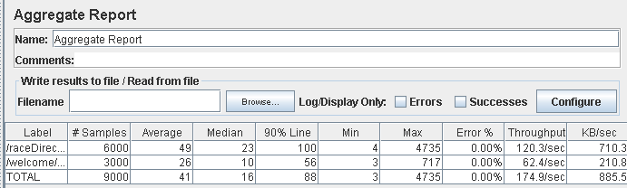

Performance thread results: 10,492 per minute

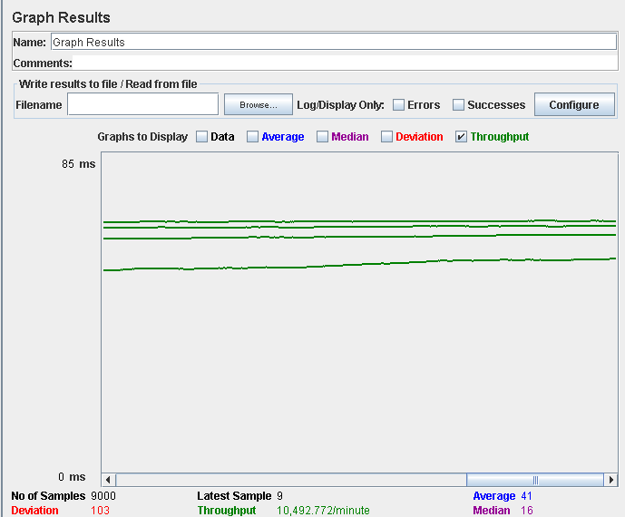

Computer performance:

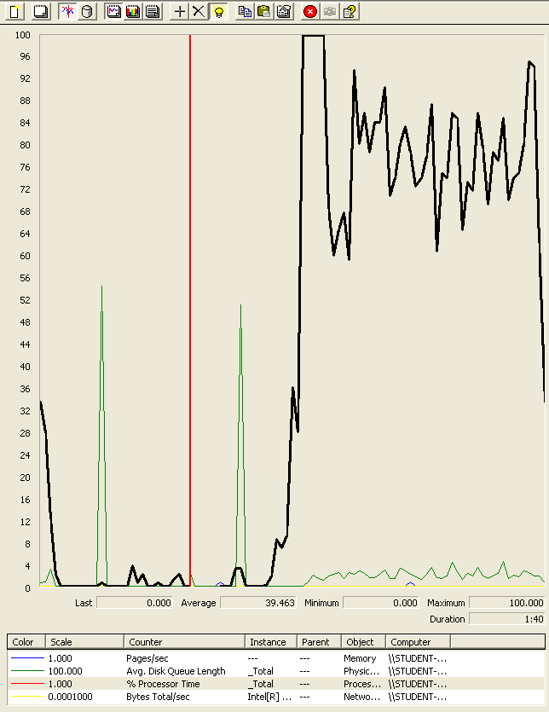

### Analysis results:

250 users and 10 loops: the application runs perfectly.

300 users and 10 loops: the application runs perfectly.

## Use case 4:

### As a not authenticated actor I want to register as a Rider

Number of Threads (users): 250

Ramp-Up Period (in seconds): 1

Loop count: 10

Performance test 90% results: Total 371ms.

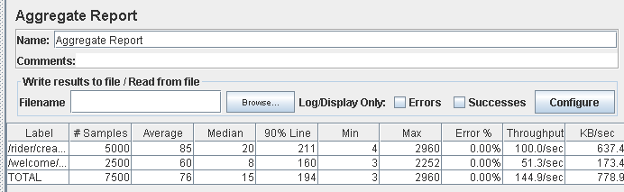

Performance thread results: 8,694 per minute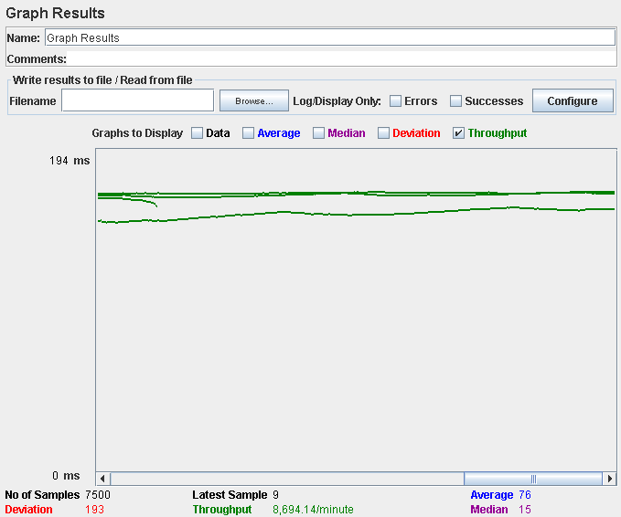

Number of Threads (users): 250

Ramp-Up Period (in seconds): 1

Loop count: 10

Performance test 90% results: Total 180ms

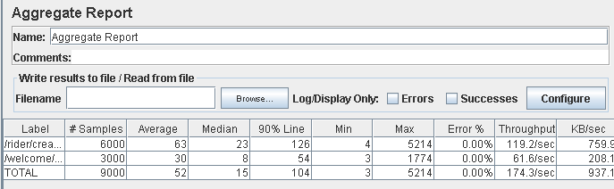

Performance thread results: 10,458 per minute

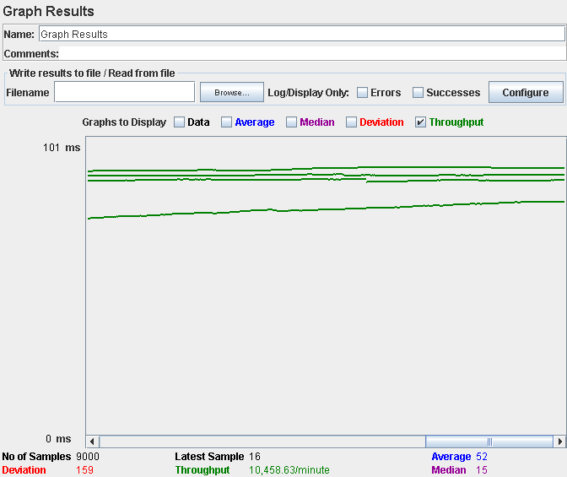

Computer performance:

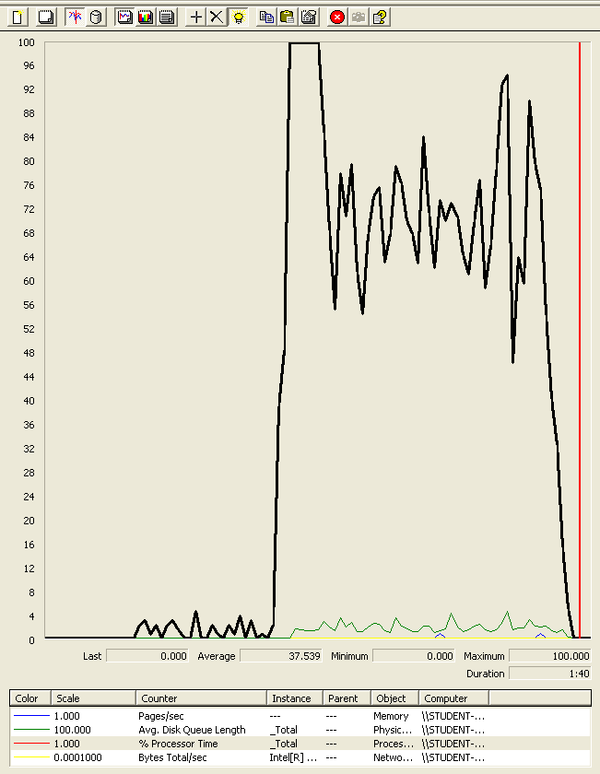

### Analysis results:

250 users and 10 loops: the application runs perfectly.

300 users and 10 loops: the application runs perfectly.

## Use case 5:

### As a not authenticated actor I want to register as a Sponsor

Number of Threads (users): 250

Ramp-Up Period (in seconds): 1

Loop count: 10

Performance test 90% results: Total 59ms.

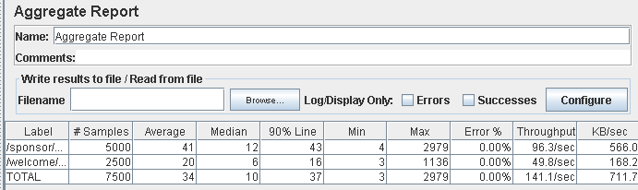

Performance thread results: 8,467 per minute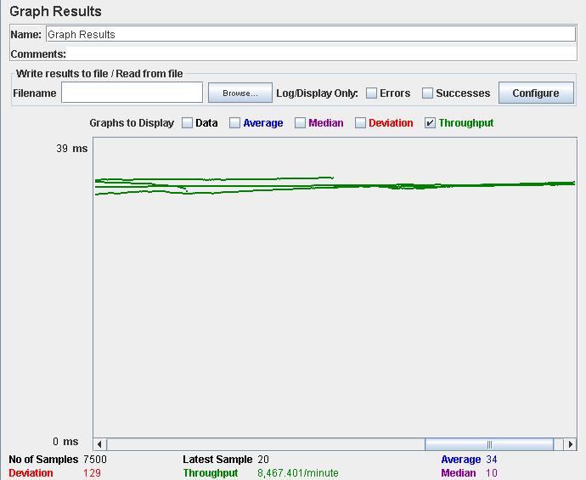

Number of Threads (users): 250

Ramp-Up Period (in seconds): 1

Loop count: 10

Performance test 90% results: Total 89ms

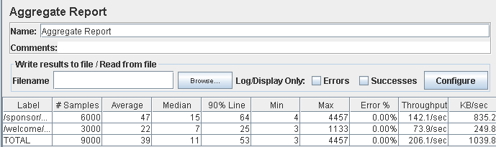

Performance thread results: 12,367 per minute

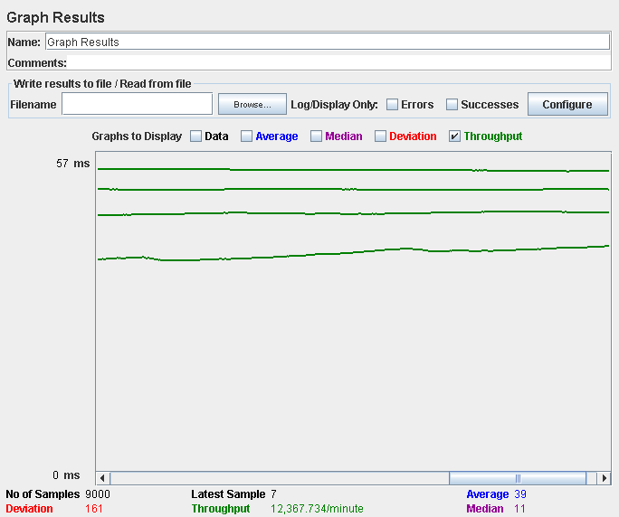

Computer performance:

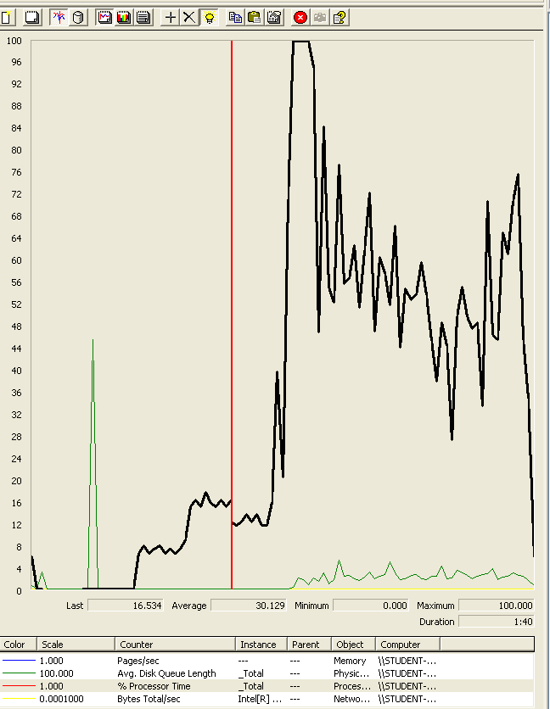

### Analysis results:

250 users and 10 loops: the application runs perfectly.

300 users and 10 loops: the application runs perfectly.

## Use case 6:

### As a not authenticated actor I want to list and display the circuits

Number of Threads (users): 250

Ramp-Up Period (in seconds): 1

Loop count: 10

Performance test 90% results: Total 40ms.

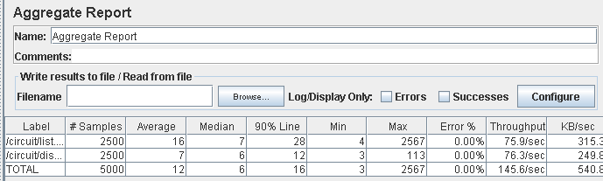

Performance thread results: 8,737 per minute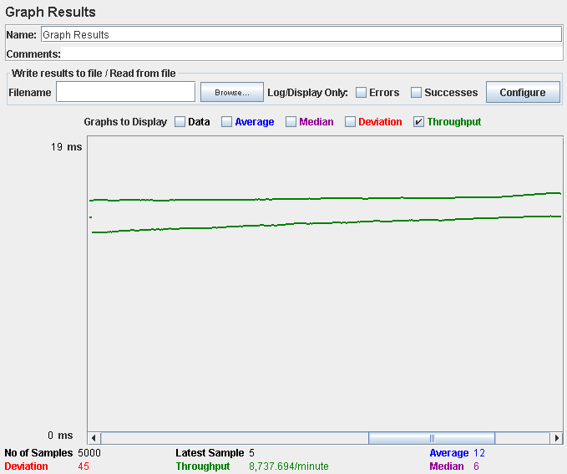

Number of Threads (users): 250

Ramp-Up Period (in seconds): 1

Loop count: 10

Performance test 90% results: Total 103ms

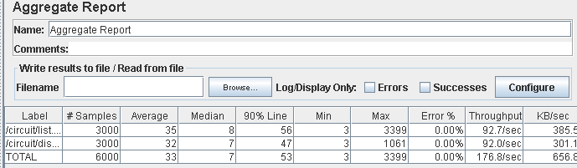

Performance thread results: 10,608 per minute

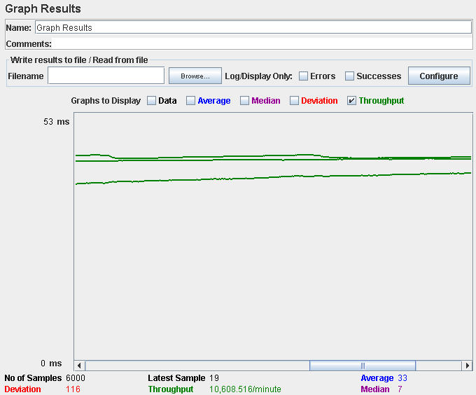

Computer performance:

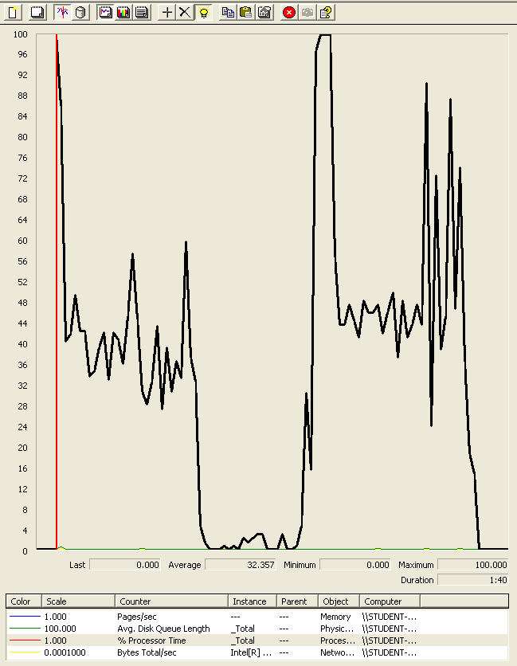

### Analysis results:

250 users and 10 loops: the application runs perfectly.

300 users and 10 loops: the application runs perfectly.

## Use case 7:

### As an administrator I want to create administrators account

Number of Threads (users): 250

Ramp-Up Period (in seconds): 1

Loop count: 10

Performance test 90% results: Total 371ms.

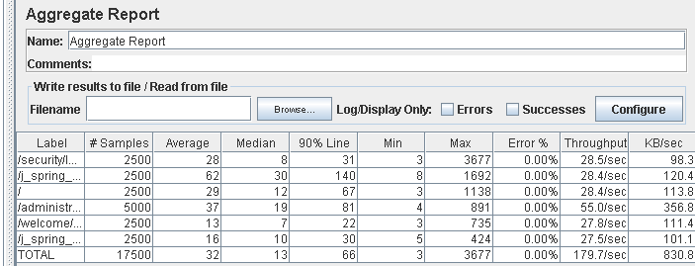

Performance thread results: 10,783 per minute

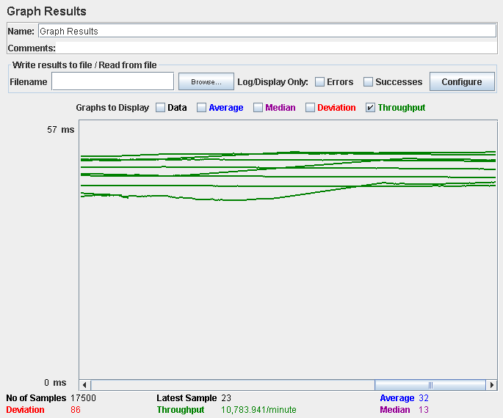

Number of Threads (users): 300

Ramp-Up Period (in seconds): 1

Loop count: 10

Performance test 90% results: Total 3,618ms

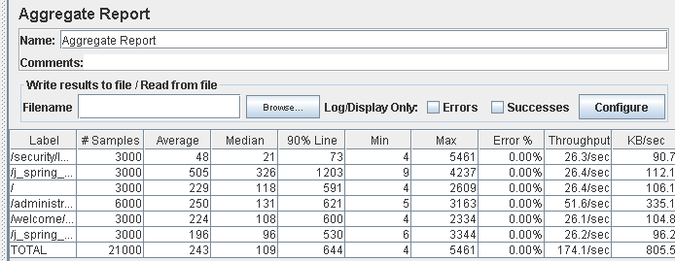

Performance thread results: 10,448 per minute

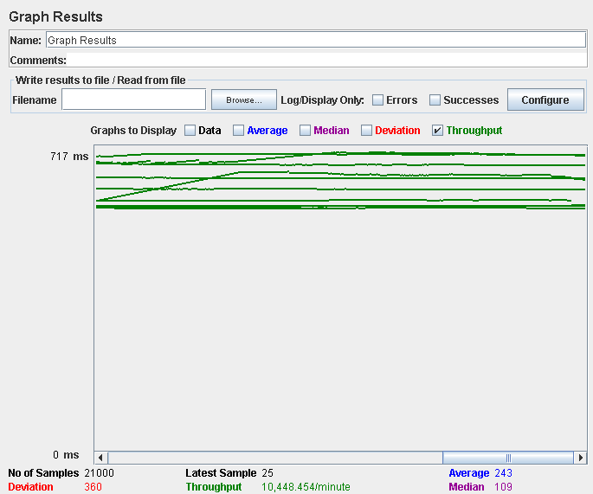

Computer performance:

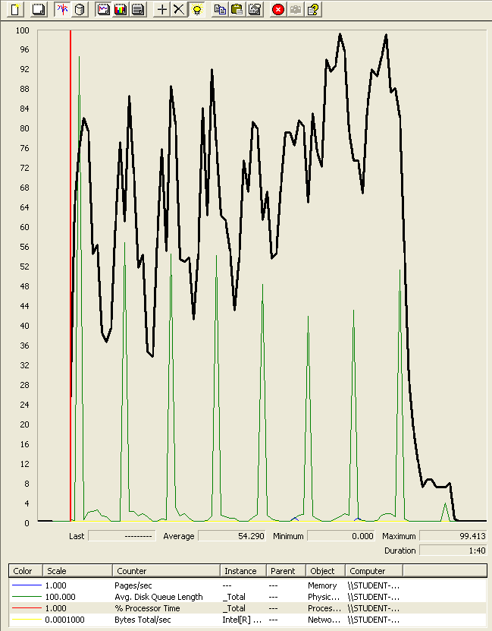

### Analysis results:

250 users and 10 loops: the application runs perfectly.

300 users and 10 loops: the application runs perfectly.

## Use case 8:

### As an authenticated actor I want to edit my personal data

Number of Threads (users): 250

Ramp-Up Period (in seconds): 1

Loop count: 10

Performance test 90% results: Total 359ms

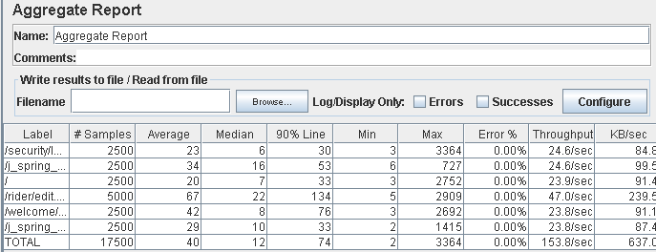

Performance thread results: 9,225 per minute

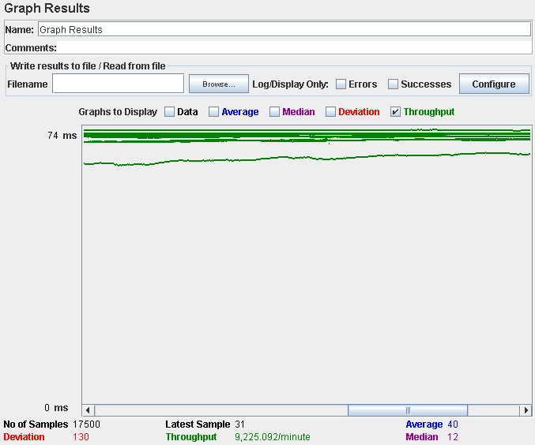

Number of Threads (users): 300

Ramp-Up Period (in seconds): 1

Loop count: 10

Performance test 90% results: Total 4,432.

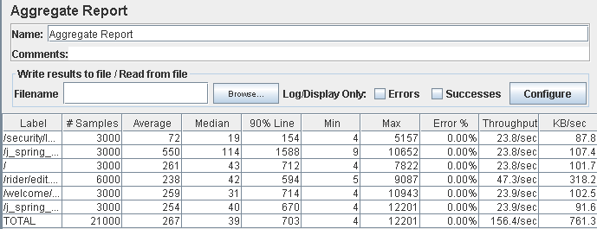

Performance thread results: 8,310 per minute

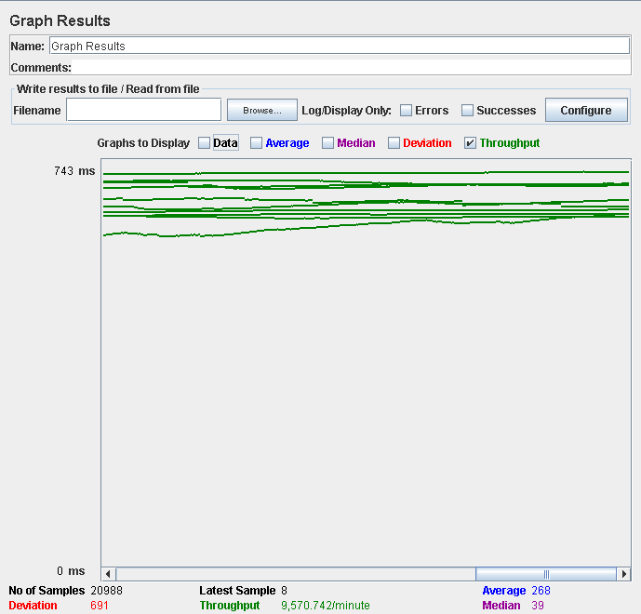

Computer performance:

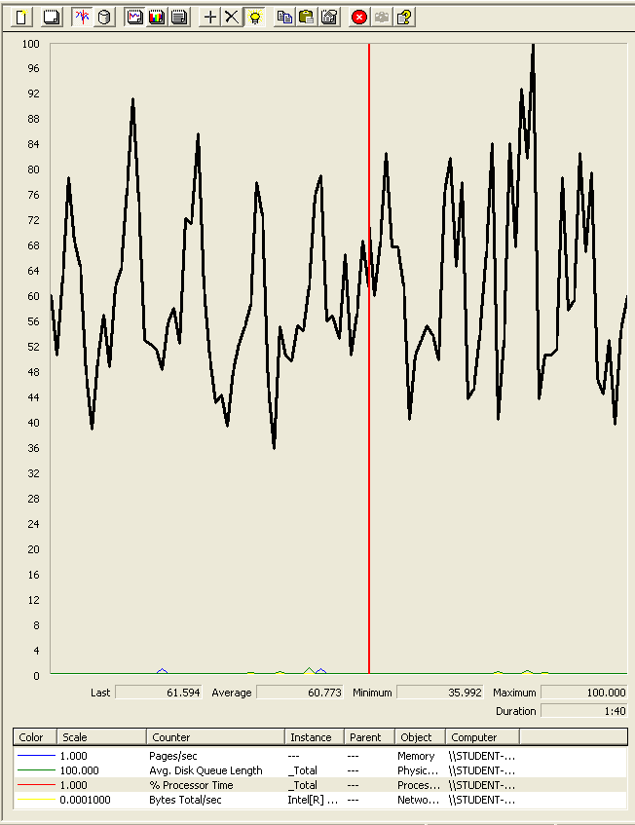

### Analysis results:

250 users and 10 loops: the application runs perfectly.

300 users and 10 loops: the application runs perfectly.

## Use case 9:

### As an admin I want to display a list of suspicious actors, ban or unban those actors.

Number of Threads (users): 250

Ramp-Up Period (in seconds): 1

Loop count: 10

Performance test 90% results: Total 1,396ms.

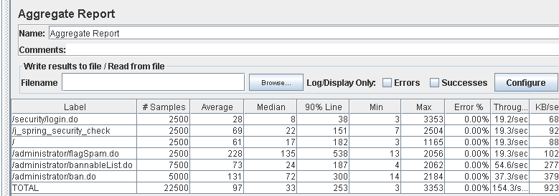

Performance thread results: 9,256 per minute

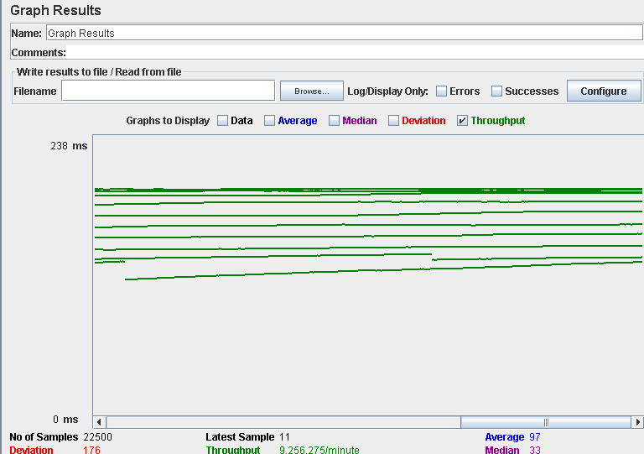

Number of Threads (users): 300

Ramp-Up Period (in seconds): 1

Loop count: 10

Performance test 90% results: Total 6,734ms

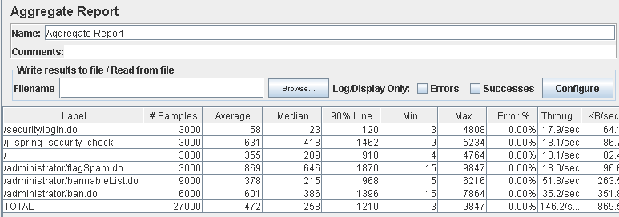

Performance thread results: 8,772 per minute

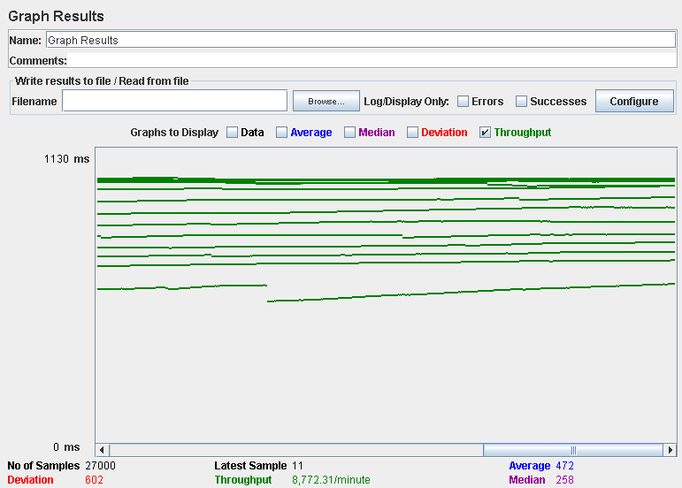

Computer performance:

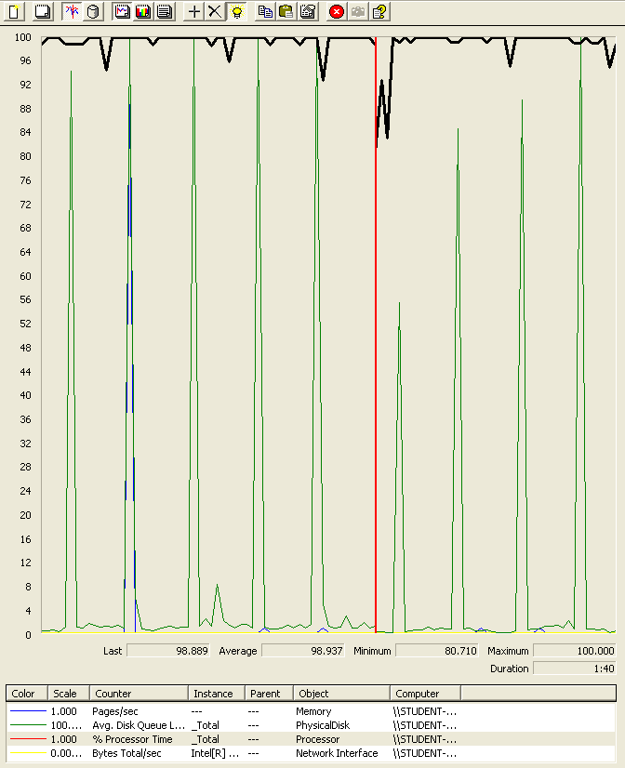

### Analysis results:

250 users and 10 loops: the application runs perfectly.

300 users and 10 loops: the application runs perfectly.

## Use case 10:

### As an authenticated user I want to list and display the riders and also list and display their social profiles

Number of Threads (users): 250

Ramp-Up Period (in seconds): 1

Loop count: 10

Performance test 90% results: Total 730ms.

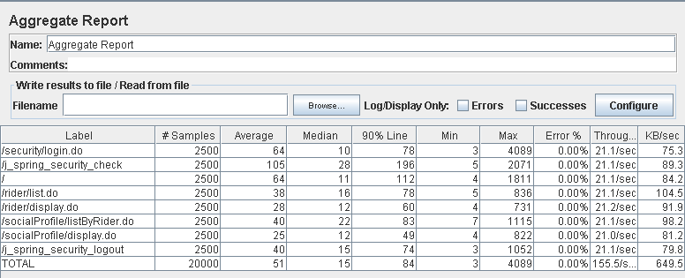

Performance thread results: 9,331 per minute

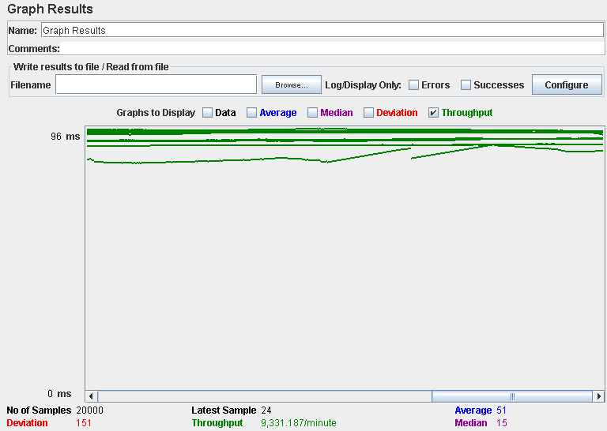

Number of Threads (users): 300

Ramp-Up Period (in seconds): 1

Loop count: 10

Performance test 90% results: Total 1,113ms

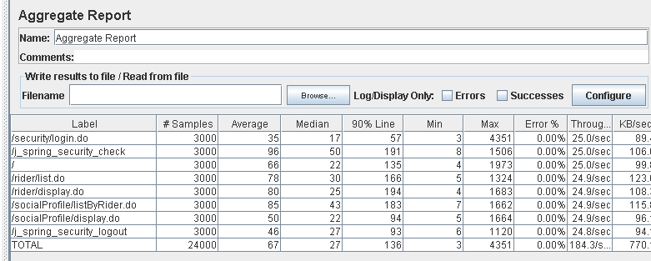

Performance thread results: 11,058 per minute

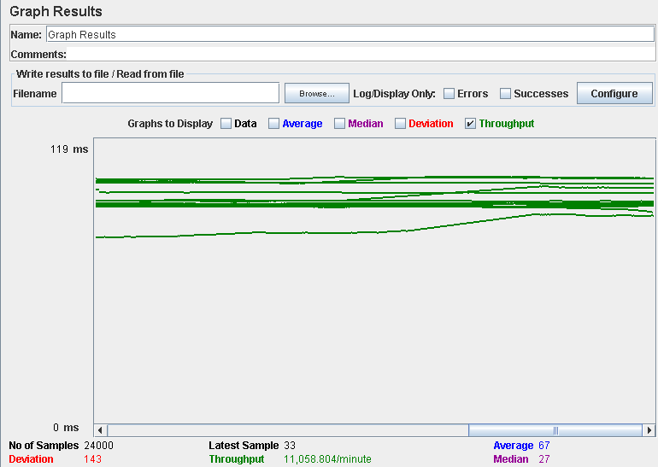

Computer performance:

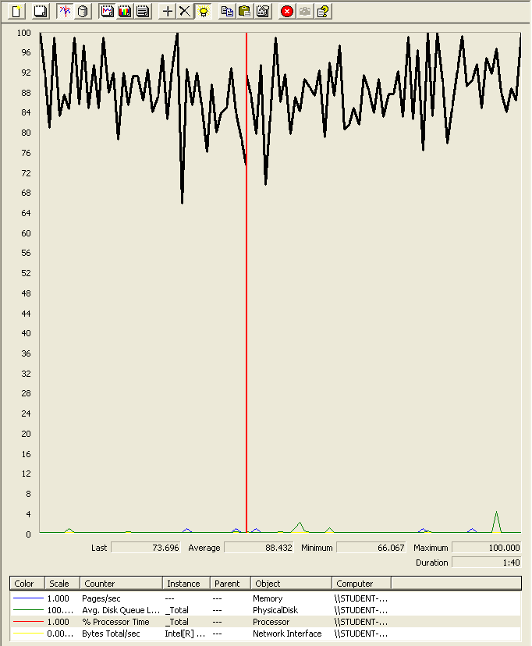

### Analysis results:

250 users and 10 loops: the application runs perfectly.

300 users and 10 loops: the application runs perfectly.

## Use case 11:

### As an authenticated actor I want to send a message to others actors of the system.

Number of Threads (users): 200

Ramp-Up Period (in seconds): 1

Loop count: 10

Performance test 90% results: Total 2,221ms

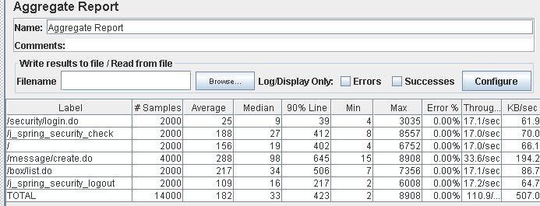

Performance thread results: 6,651 per minute

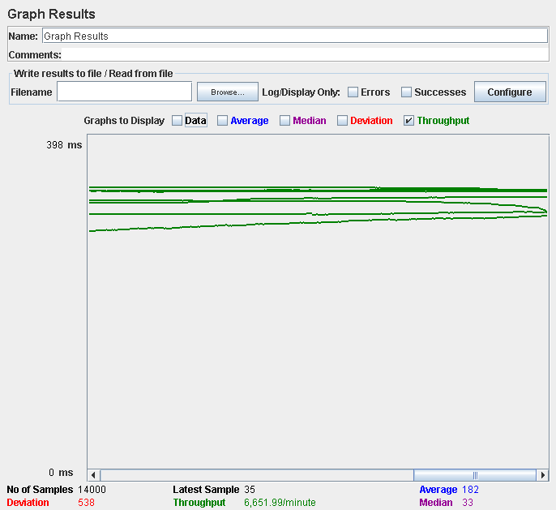

Number of Threads (users): 300

Ramp-Up Period (in seconds): 1

Loop count: 10

Performance test 90% results: Total 11,324ms.

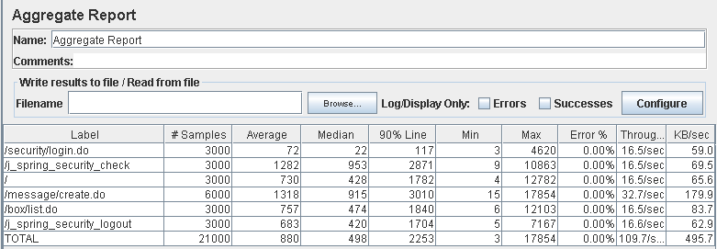

Performance thread results: 6,579 per minute

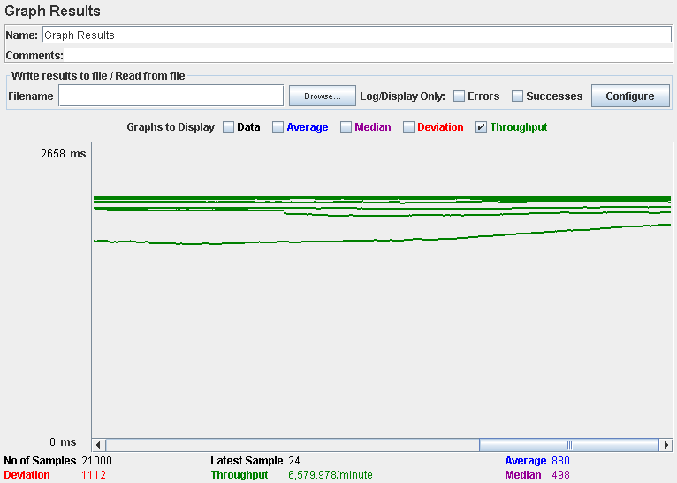

Computer performance:

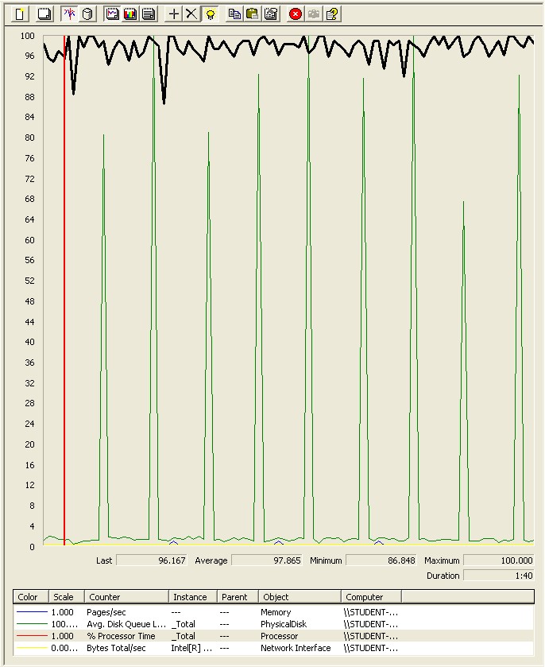

### Analysis results:

250 users and 10 loops: the application runs perfectly.

300 users and 10 loops: the application runs without errors but the time spend creating the message is a bit high. We believe it is a processor bottleneck problem, also the disk is pretty busy.

## Use case 12:

### As an authenticated user I want create new message boxes.

Number of Threads (users): 200

Ramp-Up Period (in seconds): 1

Loop count: 10

Performance test 90% results: Total 11,245ms

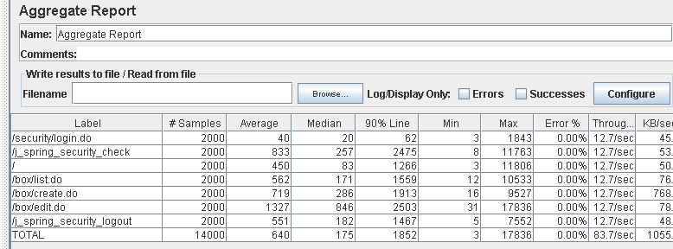

Performance thread results: 6,651 per minute



Number of Threads (users): 250

Ramp-Up Period (in seconds): 1

Loop count: 10

Performance test 90% results: Total 12,257ms.

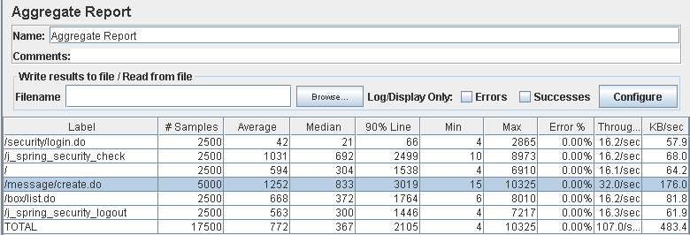

Performance thread results: 6,419 per minute

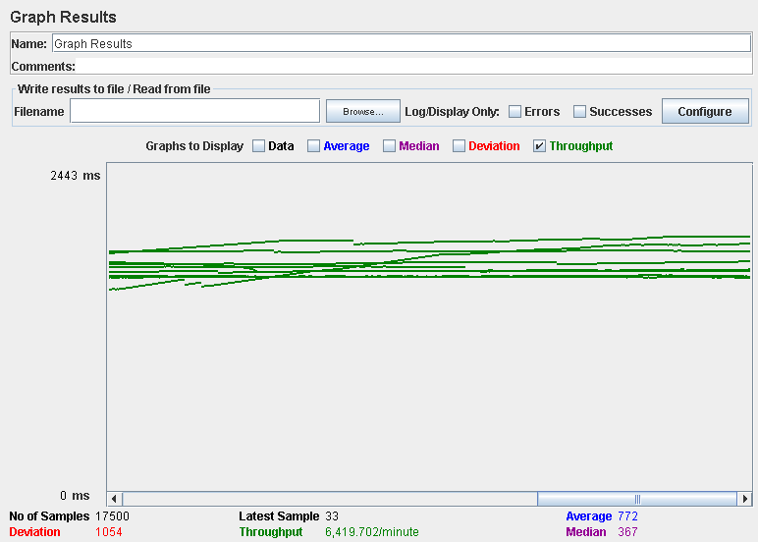

Computer performance:

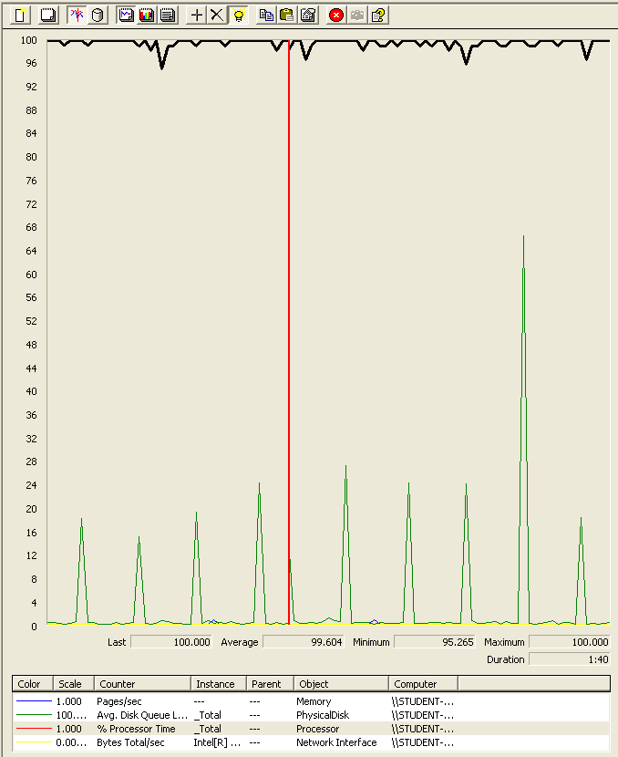

### Analysis results:

200 users and 10 loops: the application runs perfectly

250 users and 10 loops: the application runs without errors but the time spending the action creating the box is high. We believe is a processor bottleneck problem.

## Use case 13:

### As an administrator I want to manage the categories of the system.

Number of Threads (users): 250

Ramp-Up Period (in seconds): 1

Loop count: 10

Performance test 90% results: Total 7,736ms.

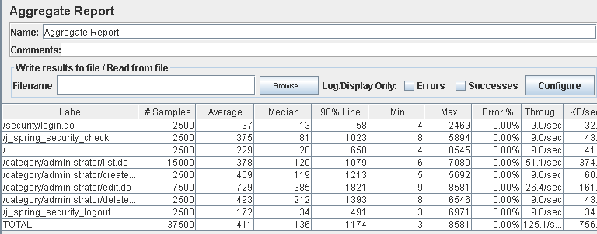

Performance thread results: 7,507 per minute

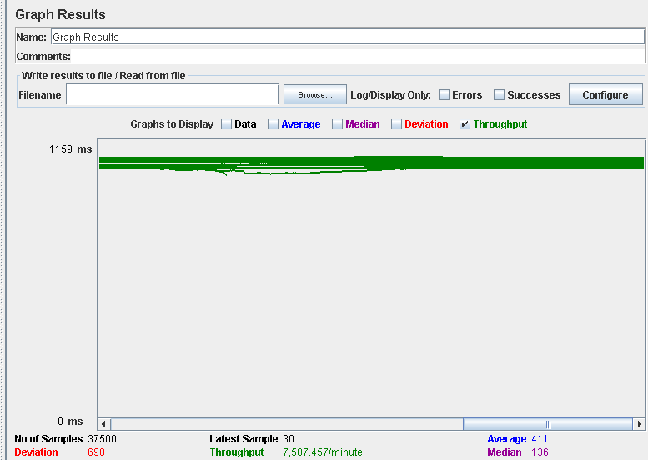

Number of Threads (users): 300

Ramp-Up Period (in seconds): 1

Loop count: 10

Performance test 90% results: Total 40,182

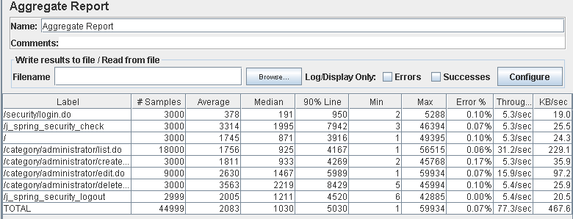

Performance thread results: 4,668 per minute

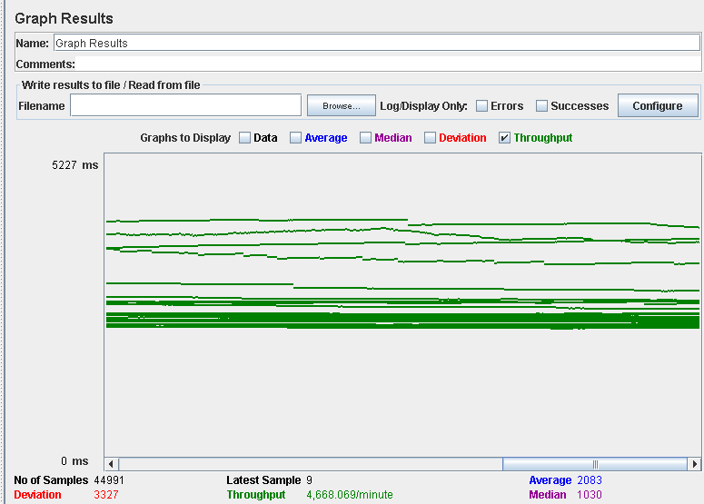

Computer performance:

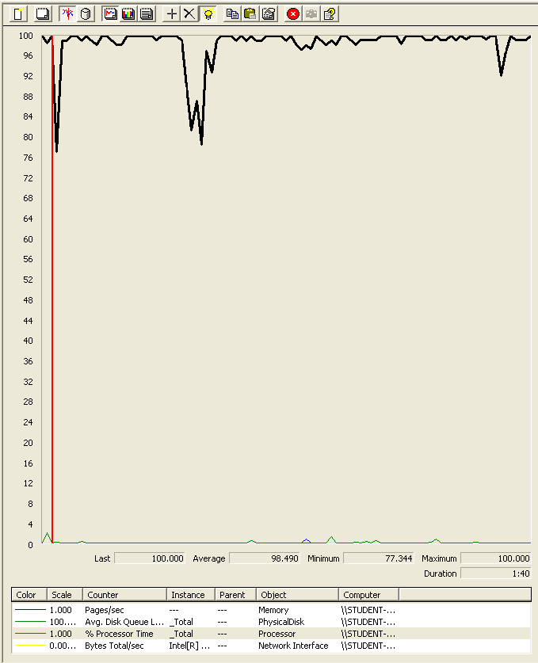

### Analysis results:

250 users and 10 loops: the application runs perfectly

300 users and 10 loops: the application have errors and the times are really high (8429ms). We believe is a processor bottleneck problem.

## Use case 14:

### As an admin I want to broadcast a message to all of the actors of the system

Number of Threads (users): 250

Ramp-Up Period (in seconds): 1

Loop count: 10

Performance test 90% results: Total 321ms.

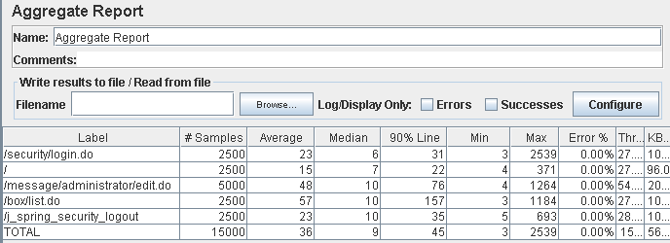

Performance thread results: 9,241 per minute

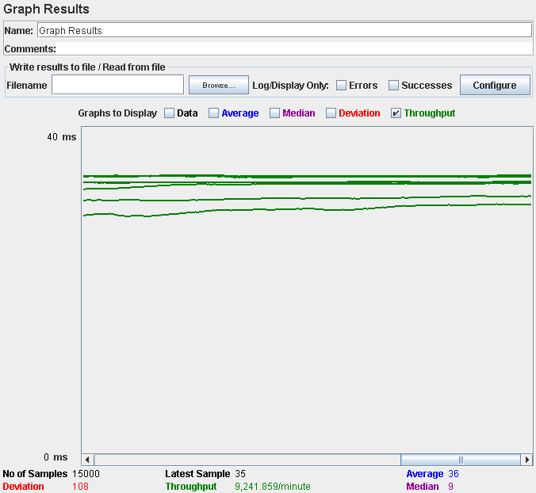

Number of Threads (users): 300

Ramp-Up Period (in seconds): 1

Loop count: 10

Performance test 90% results: Total 2,228ms

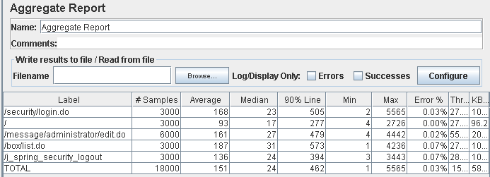

Performance thread results: 9,511 per minute

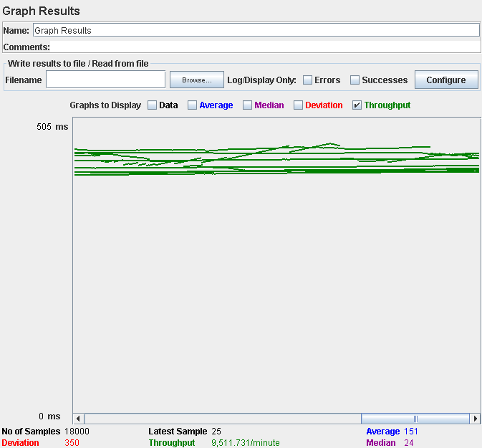

Computer performance:

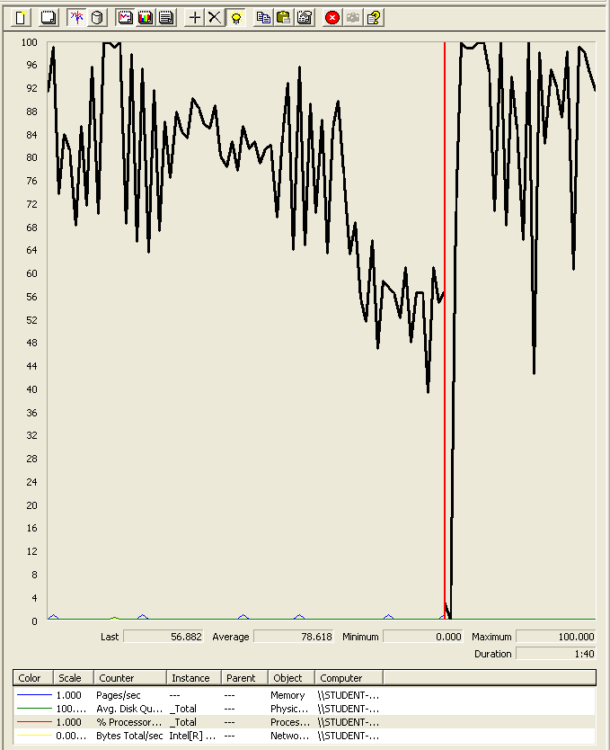

### Analysis results:

250 users and 10 loops: the application runs perfectly.

300 users and 10 loops: the application have errors and the times are really high. We believe is a processor bottleneck problem.

## Use case 15:

### As a rider I want to manage my victories on my palmares.

Number of Threads (users): 250

Ramp-Up Period (in seconds): 1

Loop count: 10

Performance test 90% results: Total 405ms.

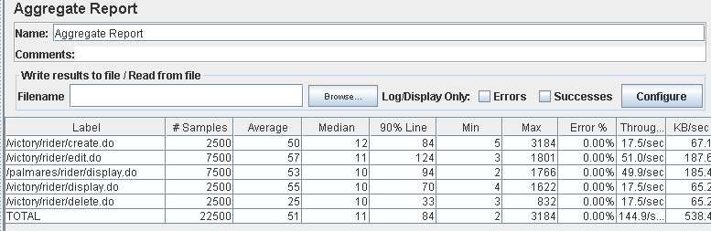

Performance thread results: 8,692 per minute

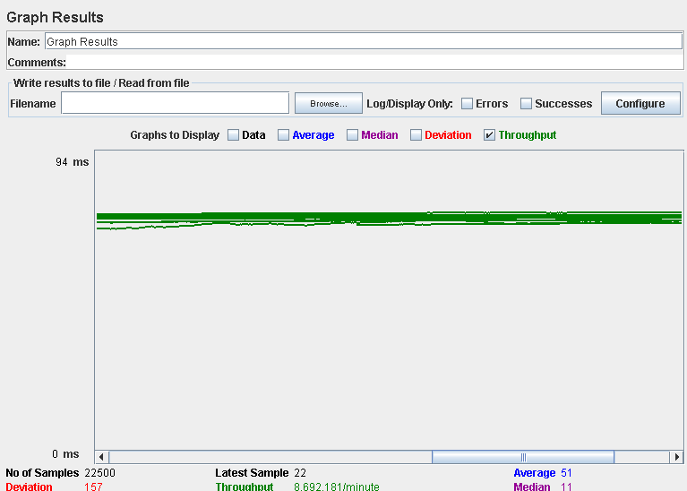

Number of Threads (users): 300

Ramp-Up Period (in seconds): 1

Loop count: 10

Performance test 90% results: Total 516ms

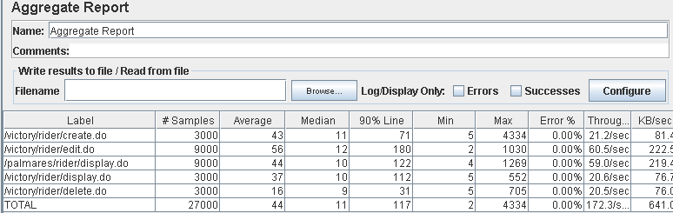

Performance thread results: 10,340 per minute

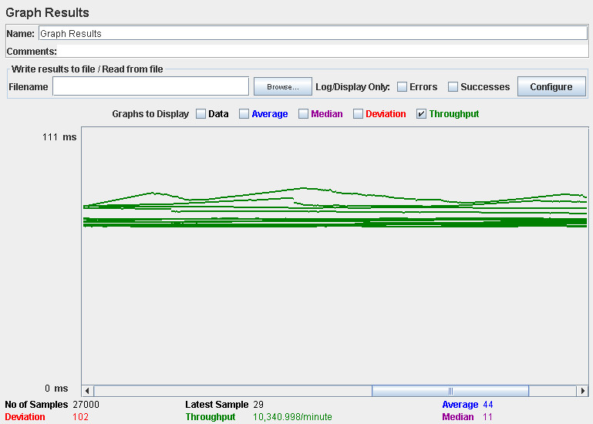

Computer performance:

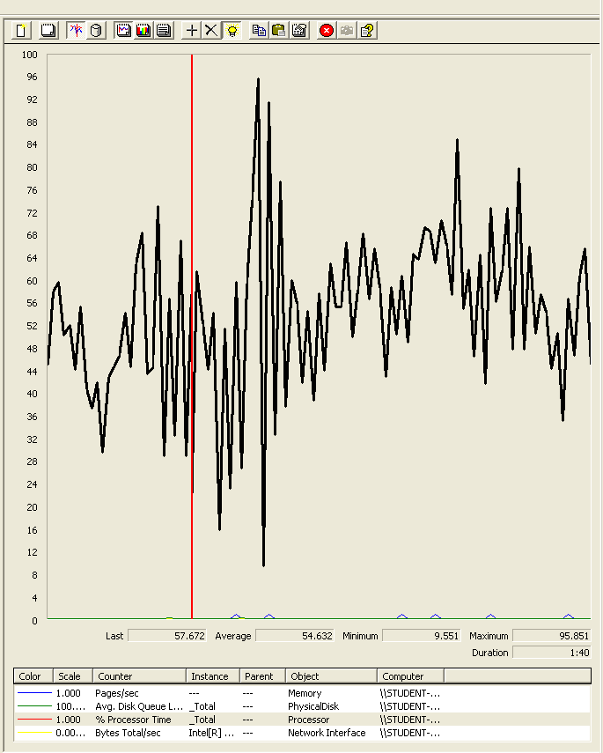

### Analysis results:

250 users and 10 loops: the application runs perfectly.

300 users and 10 loops: the application runs perfectly.

## Use case 16:

### As a rider I want to manage my laps on my palmares.

Number of Threads (users): 250

Ramp-Up Period (in seconds): 1

Loop count: 10

Performance test 90% results: Total 119ms.

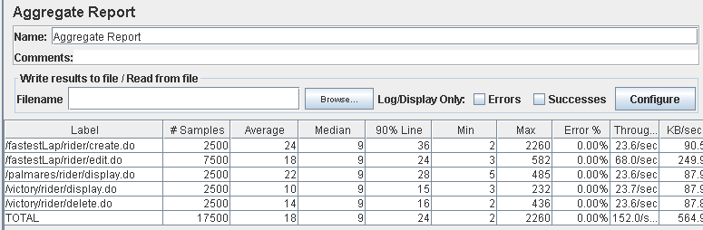

Performance thread results: 9,119 per minute

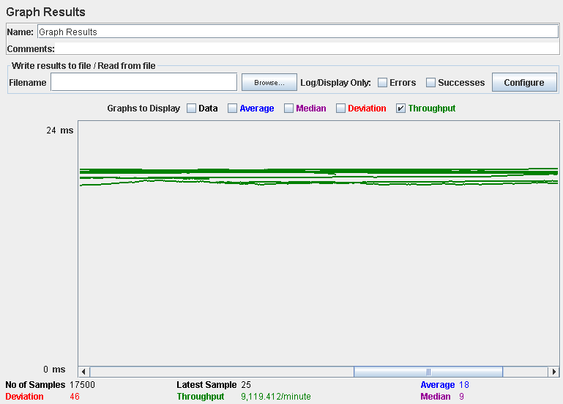

Number of Threads (users): 300

Ramp-Up Period (in seconds): 1

Loop count: 10

Performance test 90% results: Total 790ms

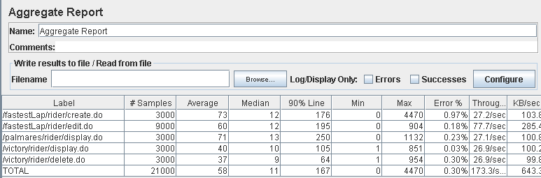

Performance thread results: 10,396 per minute

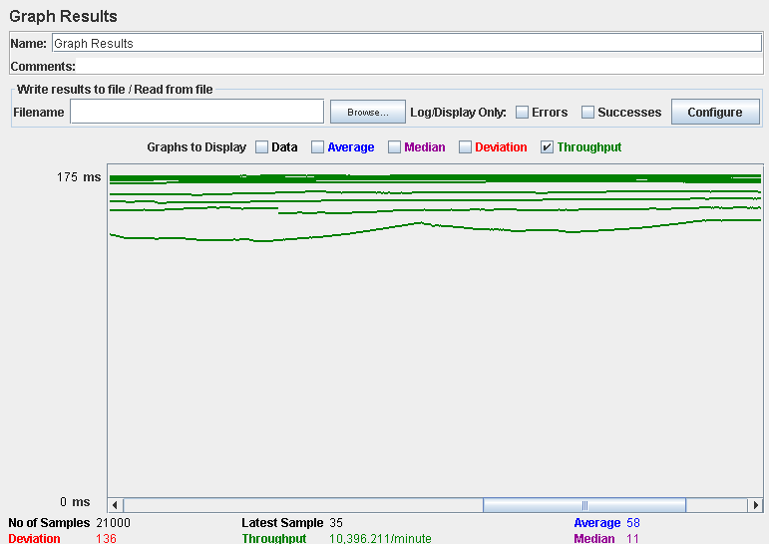

Computer performance:

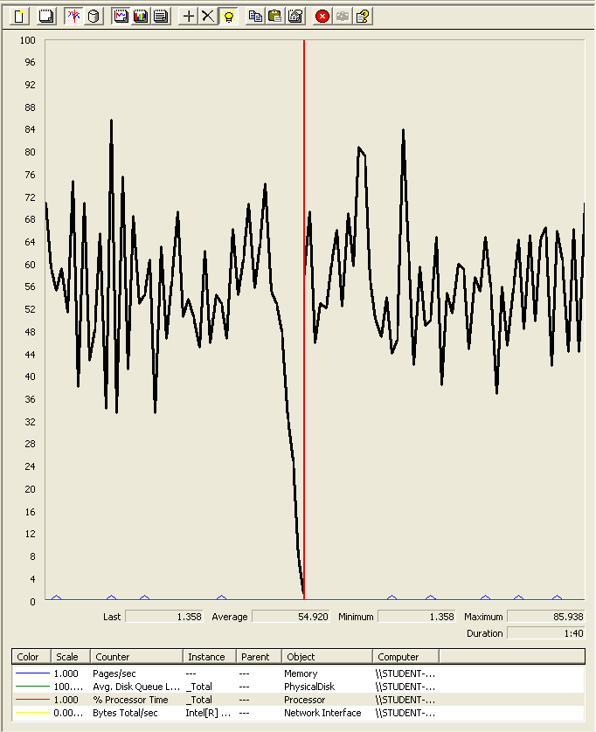

### Analysis results:

250 users and 10 loops: the application runs perfectly.

300 users and 10 loops: the application begins to have errors. It doesn’t seem like a computer problem since the computer performance doesn’t show any signs of error, but we believe that it could be the processor.

## Use case 17:

### As a rider I want to manage my podiums on my palmares.

Number of Threads (users): 250

Ramp-Up Period (in seconds): 1

Loop count: 10

Performance test 90% results: Total 400ms.

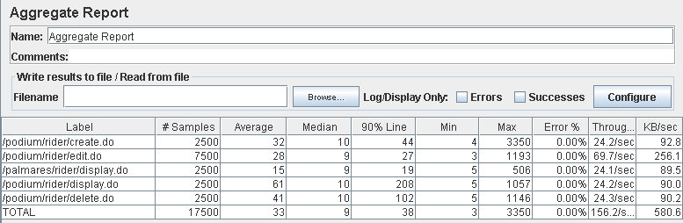

Performance thread results: 9,373 per minute

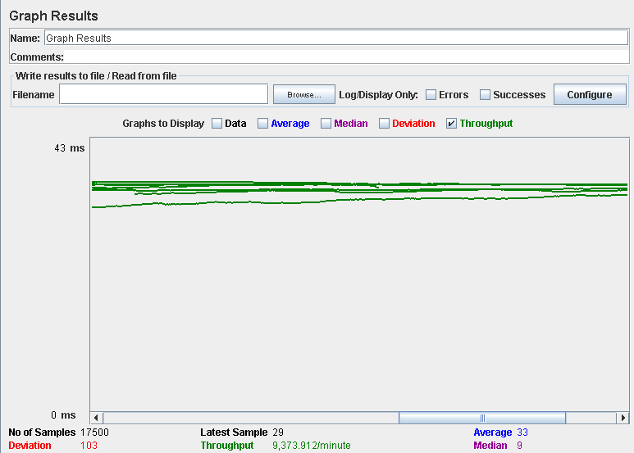

Number of Threads (users): 300

Ramp-Up Period (in seconds): 1

Loop count: 10

Performance test 90% results: Total 1,386ms

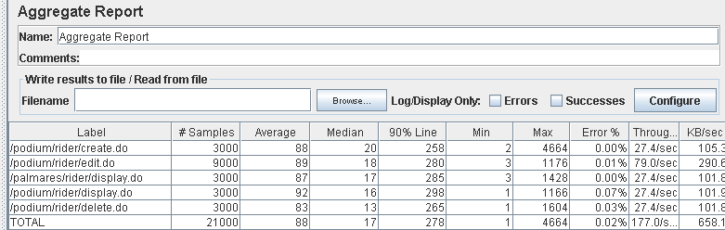

Performance thread results: 10,618 per minute

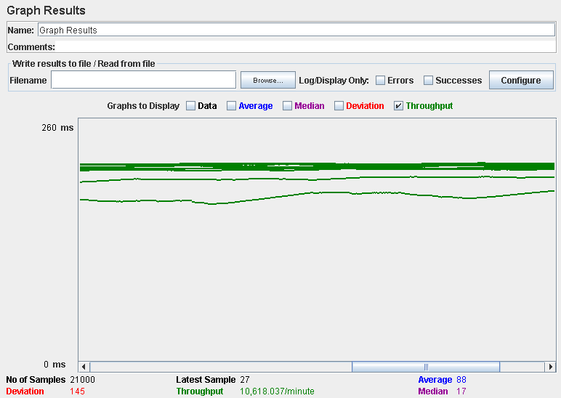

Computer performance:

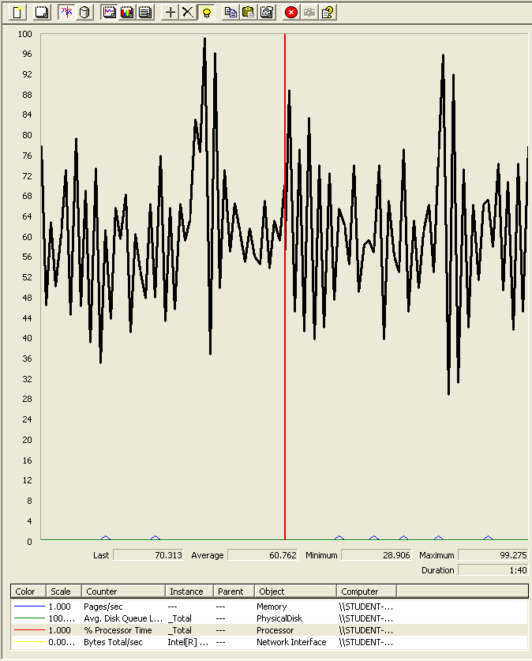

### Analysis results:

250 users and 10 loops: the application runs perfectly.

300 users and 10 loops: the application begins to have errors. We believe that it could be the processor.

## Use case 18:

### As a rider I want to manage my poles on my palmares

Number of Threads (users): 250

Ramp-Up Period (in seconds): 1

Loop count: 10

Performance test 90% results: Total 181ms.

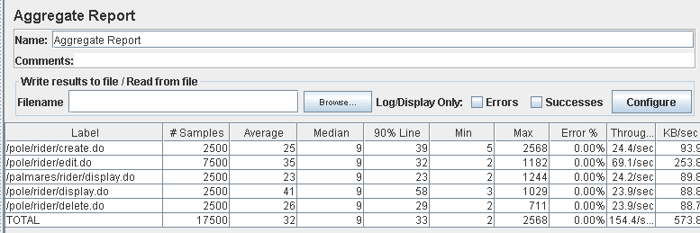

Performance thread results: 9,263 per minute

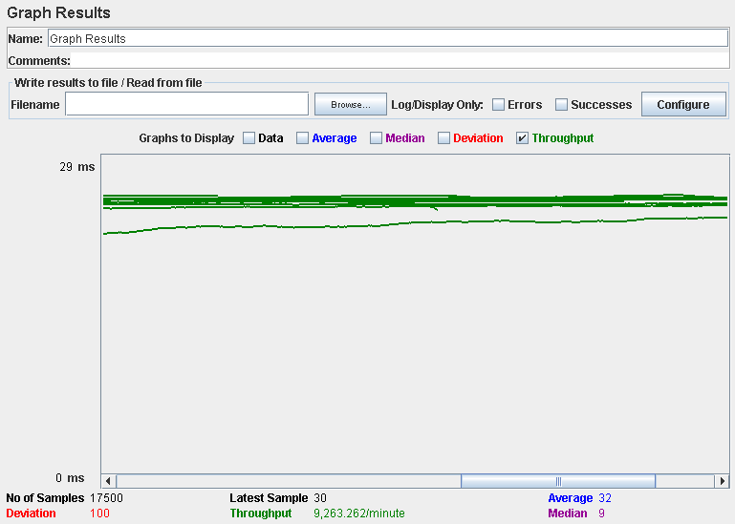

Number of Threads (users): 250

Ramp-Up Period (in seconds): 1

Loop count: 10

Performance test 90% results: Total 1,340ms

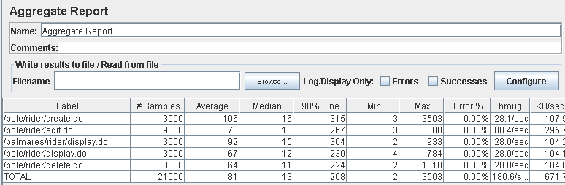

Performance thread results: 10,835 per minute

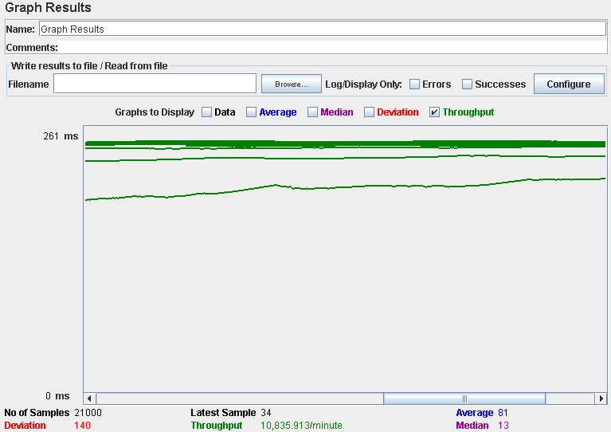

Computer performance:

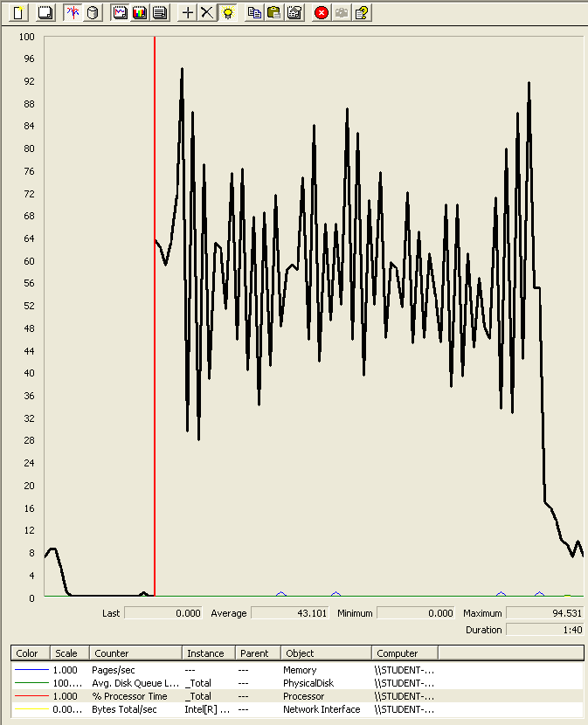

### Analysis results:

250 users and 10 loops: the application runs perfectly.

300 users and 10 loops: the application runs perfectly.

## Use case 19:

### As a rider I want to manage my podiums on my palmares

Number of Threads (users): 250

Ramp-Up Period (in seconds): 1

Loop count: 10

Performance test 90% results: Total 159ms.

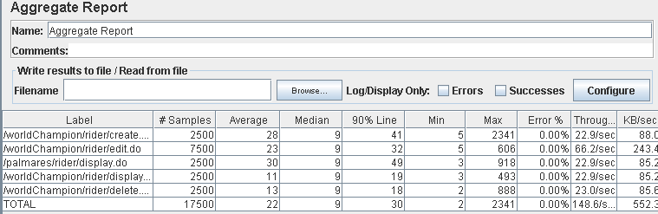

Performance thread results: 9,019 per minute

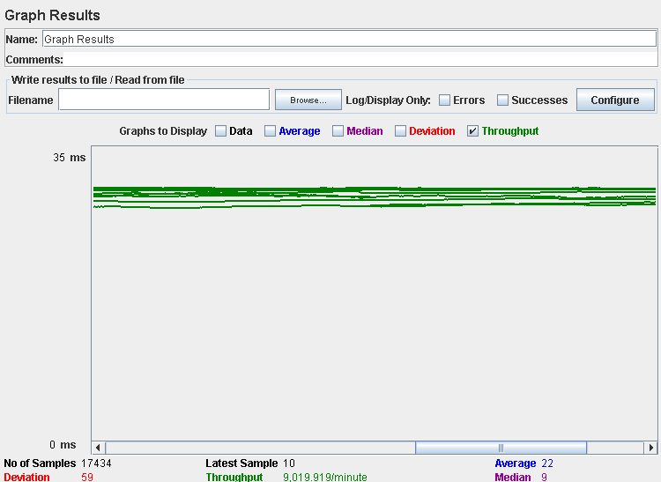

Number of Threads (users): 300

Ramp-Up Period (in seconds): 1

Loop count: 10

Performance test 90% results: Total 544ms

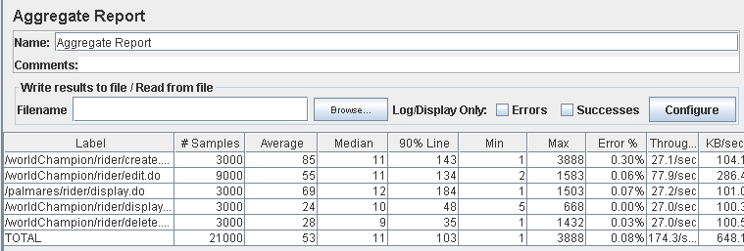

Performance thread results: 10,459 per minute

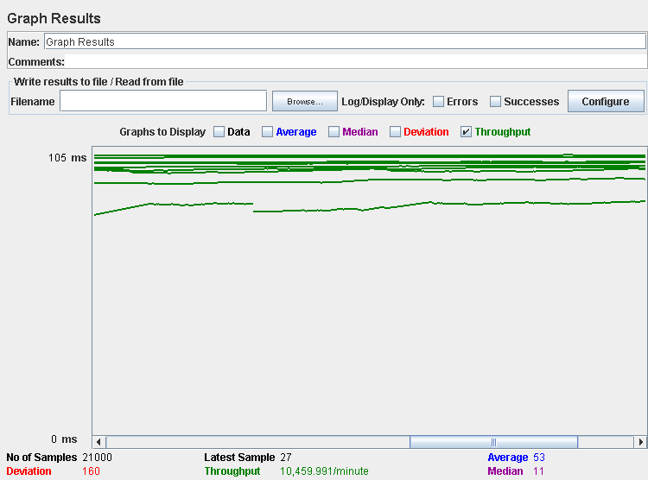

Computer performance:

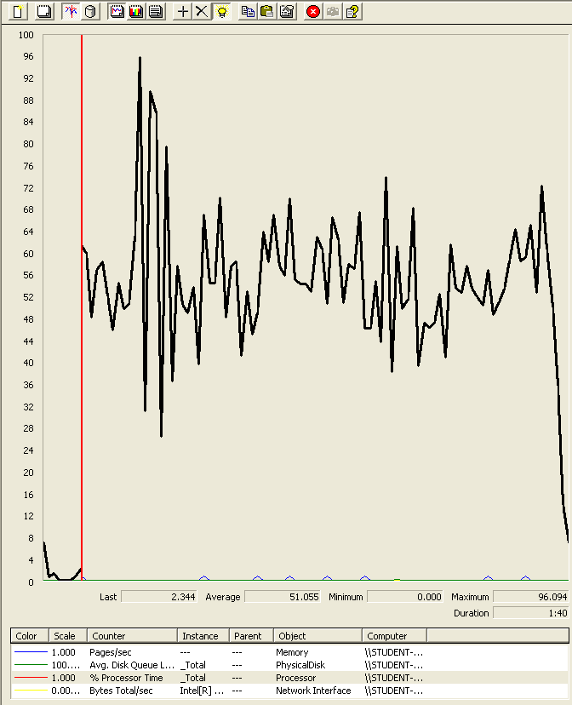

### Analysis results:

250 users and 10 loops: the application runs perfectly.

300 users and 10 loops: the application begins to have errors. It doesn’t seem like a computer problem since the computer performance doesn’t show any signs of error, but we believe that it could be the processor.

## Use case 20:

### As a Race Director I want to manage my world championships

Number of Threads (users): 250

Ramp-Up Period (in seconds): 1

Loop count: 10

Performance test 90% results: Total 9,953ms.

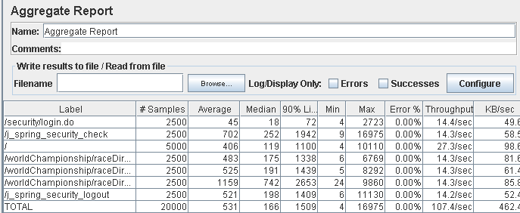

Performance thread results: 6,444 per minute

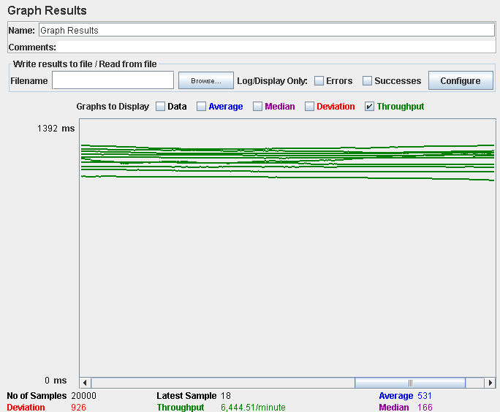

Number of Threads (users): 300

Ramp-Up Period (in seconds): 1

Loop count: 10

Performance test 90% results: Total 18,171ms

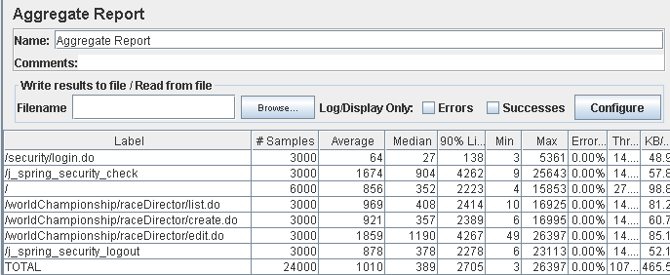

Performance thread results: 6,731 per minute

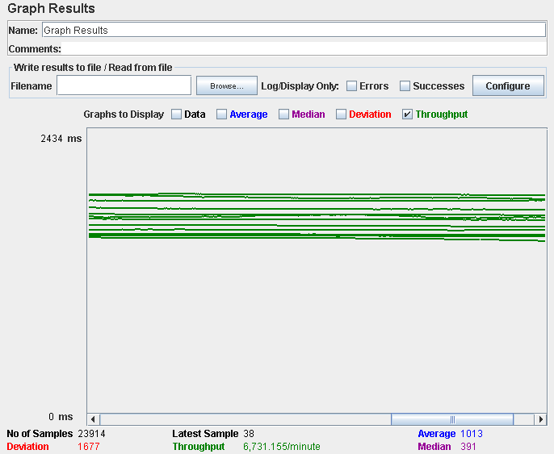

Computer performance:

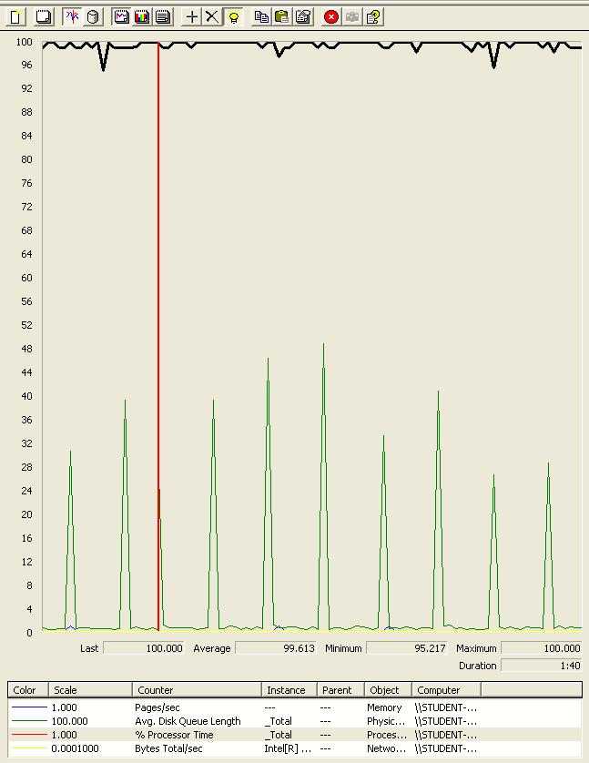

### Analysis results:

250 users and 10 loops: the application runs perfectly.

300 users and 10 loops: the application doesn’t have errors but the time spend doing the actions is very high. We believe that it could be a processor bottleneck problem.

## Use case 21:

### As a Race Director I want to manage my announcements

Number of Threads (users): 250

Ramp-Up Period (in seconds): 1

Loop count: 10

Performance test 90% results: Total 351ms.

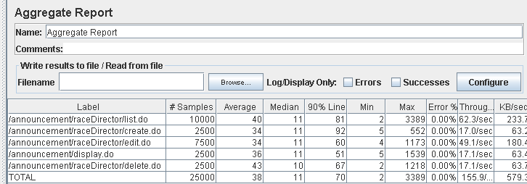

Performance thread results: 9,352 per minute

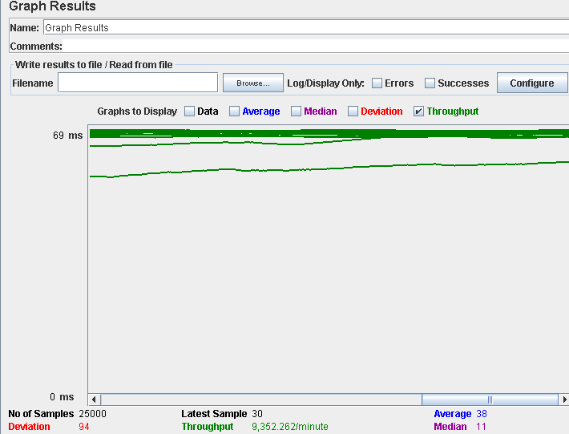

Number of Threads (users): 3000

Ramp-Up Period (in seconds): 1

Loop count: 10

Performance test 90% results: Total 2,118ms

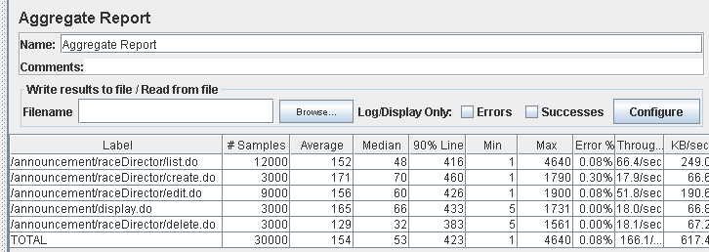

Performance thread results: 9,964 per minute

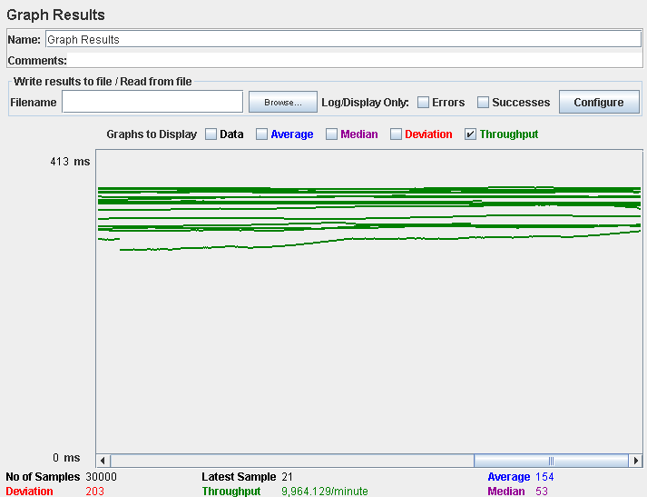

Computer performance:

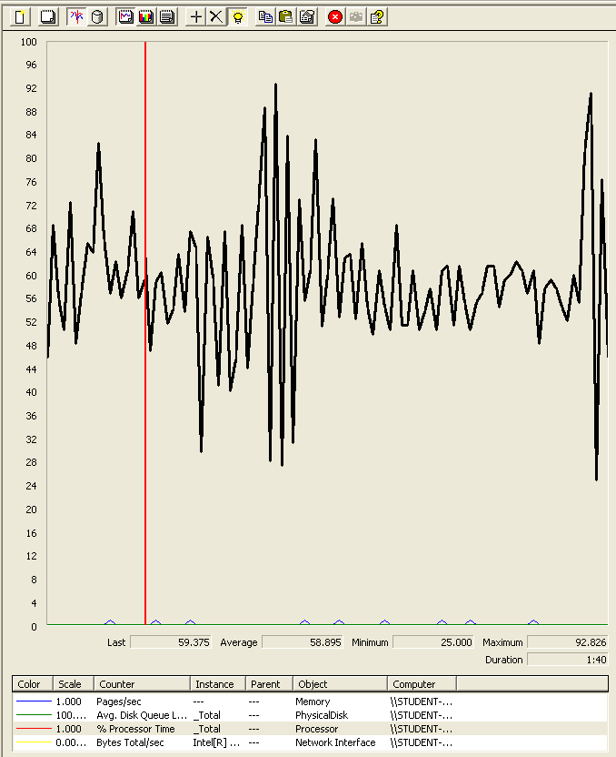

### Analysis results:

250 users and 10 loops: the application runs perfectly.

300 users and 10 loops: the application begins to have errors. We believe that it could be the processor.

## Use case 22:

### As a Race Director I want to manage the forecast of a grand prix

Number of Threads (users): 250

Ramp-Up Period (in seconds): 1

Loop count: 10

Performance test 90% results: Total 6,898ms.

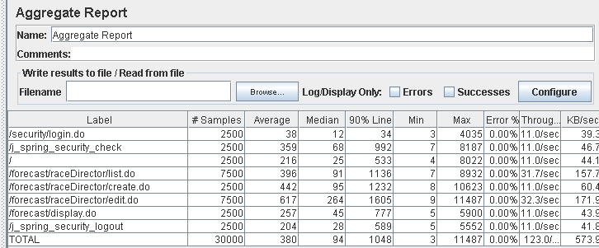

Performance thread results: 15,273 per minute

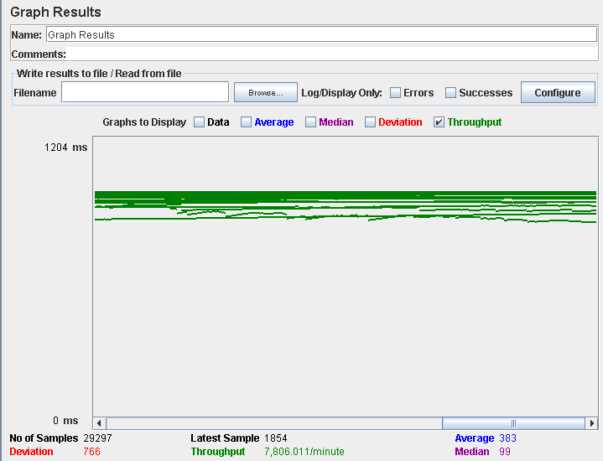

Number of Threads (users): 300

Ramp-Up Period (in seconds): 1

Loop count: 10

Performance test 90% results: Total 14,594ms

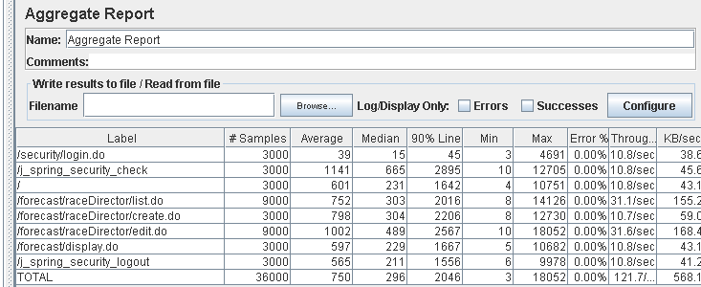

Performance thread results: 7,300 per minute

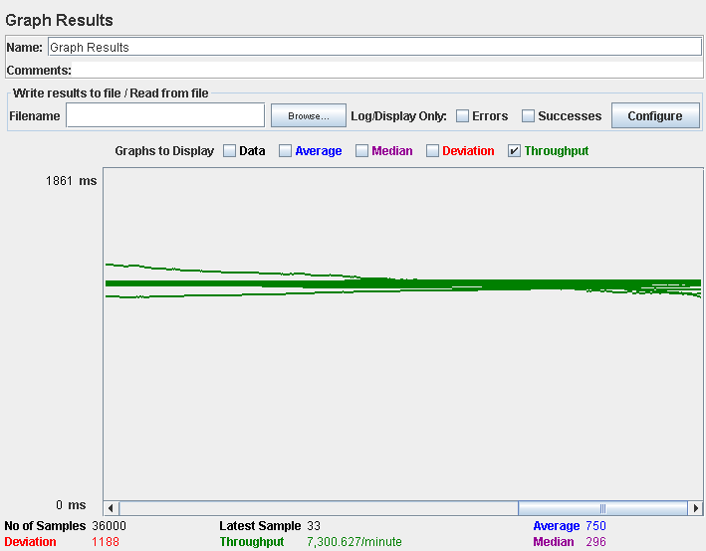

Computer performance:

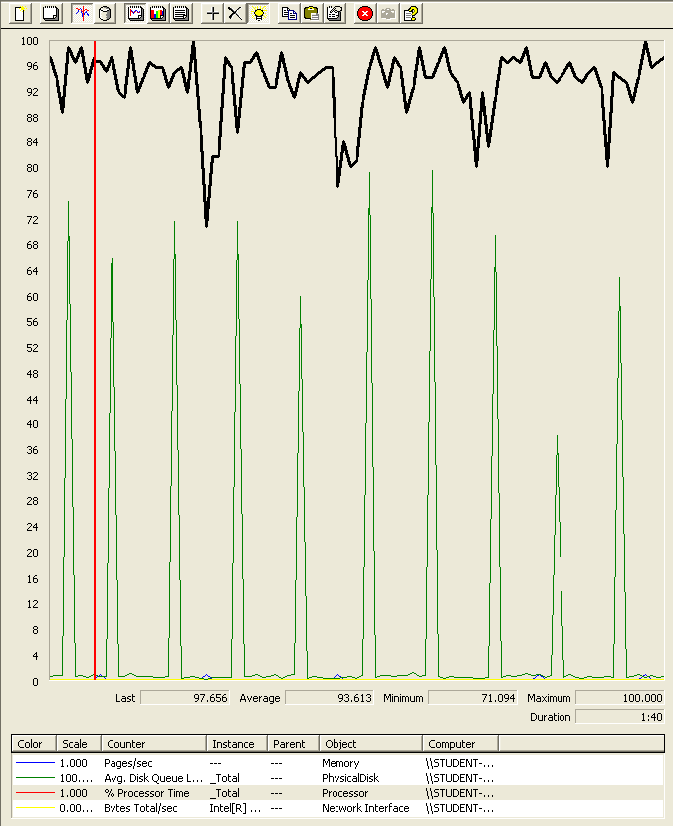

### Analysis results:

250 users and 10 loops: the application runs perfectly.

300 users and 10 loops: the application runs perfectly, the creation of the announcement is in the limits which we consider that an action could last.

## Use case 23:

### As a not authenticated actor I want to navigate to the world championship and their circuits and also navigate to the fan clubs of the riders.

Number of Threads (users): 250

Ramp-Up Period (in seconds): 1

Loop count: 10

Performance test 90% results: Total 6,652ms.

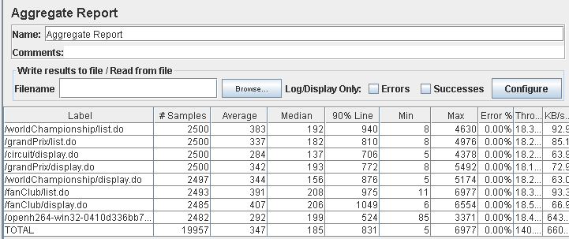

Performance thread results: 8,506 per minute

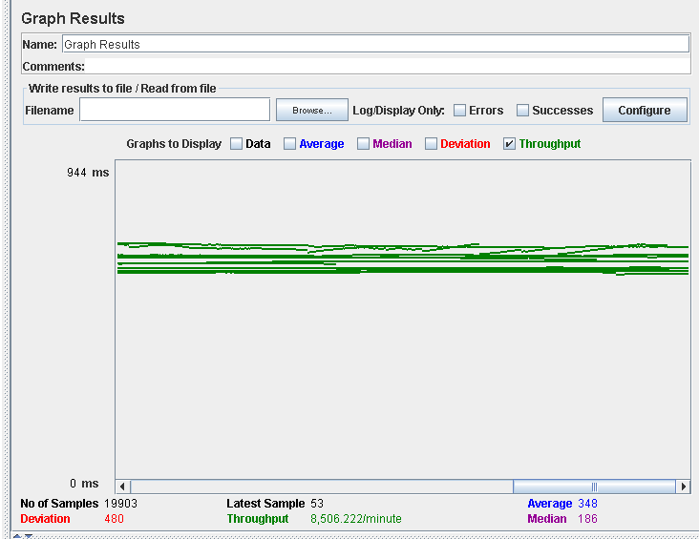

Number of Threads (users): 300

Ramp-Up Period (in seconds): 1

Loop count: 10

Performance test 90% results: Total 6,507ms

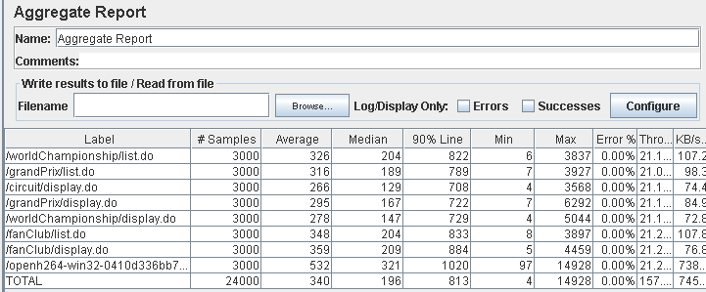

Performance thread results: 9,458 per minute

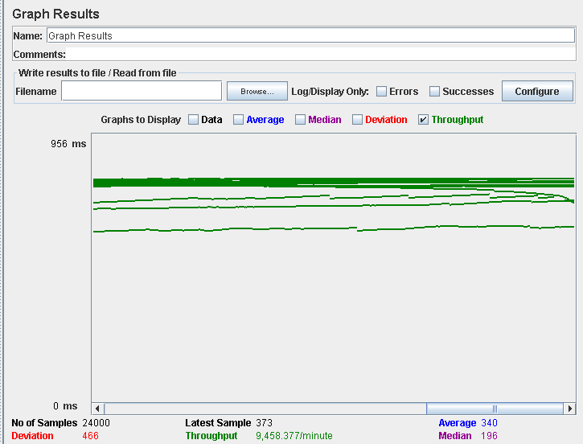

Computer performance:

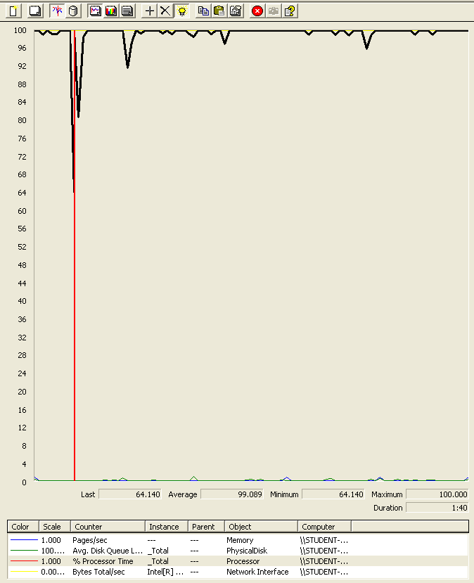

### Analysis results:

250 users and 10 loops: the application runs perfectly.

300 users and 10 loops: the application runs perfectly.

## Use case 24:

### As a Race Director I want to create and edit my grand prixes.

Number of Threads (users): 200

Ramp-Up Period (in seconds): 1

Loop count: 10

Performance test 90% results: Total 7,277ms.

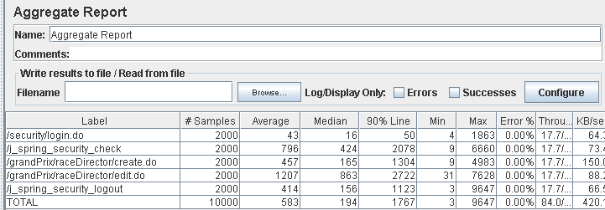

Performance thread results: 5,040 per minute

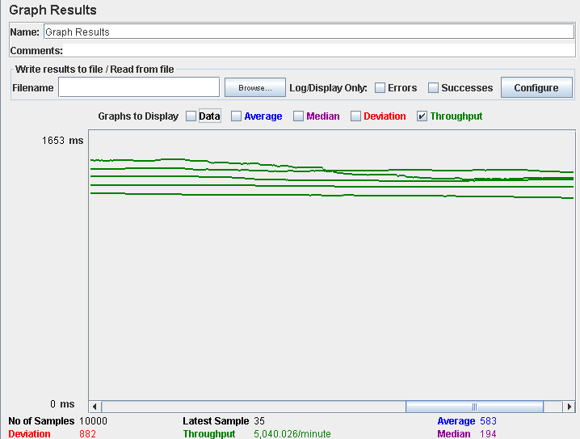

Number of Threads (users): 250

Ramp-Up Period (in seconds): 1

Loop count: 10

Performance test 90% results: Total 26,841ms

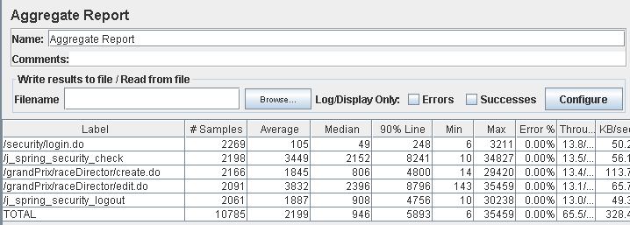

Performance thread results: 3,932 per minute

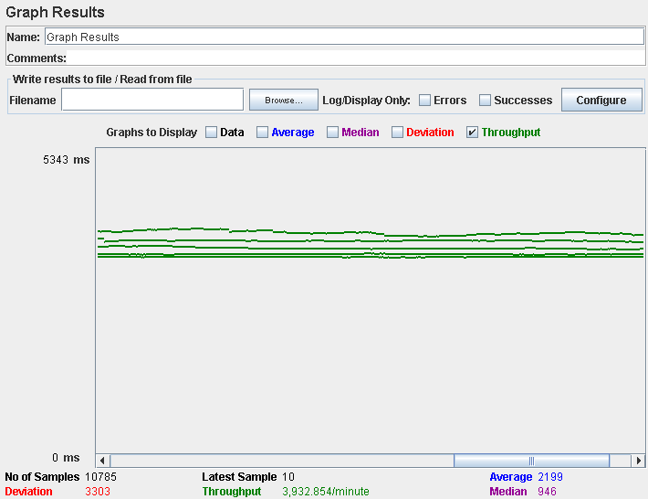

Computer performance:

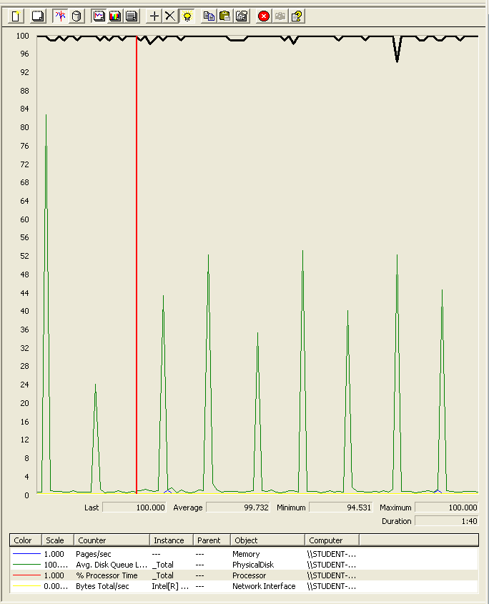

### Analysis results:

200 users and 10 loops: the application runs perfectly

250 users and 10 loops: the application doesn’t have errors but the time spend doing the actions is really high (8 secs for example). We believe is a processors bottleneck problem.

## Use case 25:

### As a Race Director I want to list, display and delete my grand prixes.

Number of Threads (users): 250

Ramp-Up Period (in seconds): 1

Loop count: 10

Performance test 90% results: Total 1,835ms.

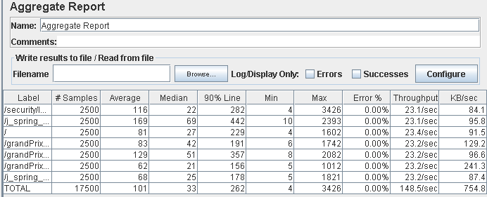

Performance thread results: 8,909 per minute

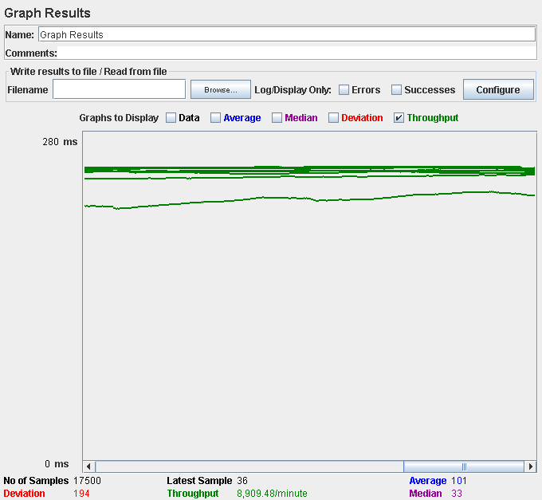

Number of Threads (users): 300

Ramp-Up Period (in seconds): 1

Loop count: 10

Performance test 90% results: Total 3,554ms

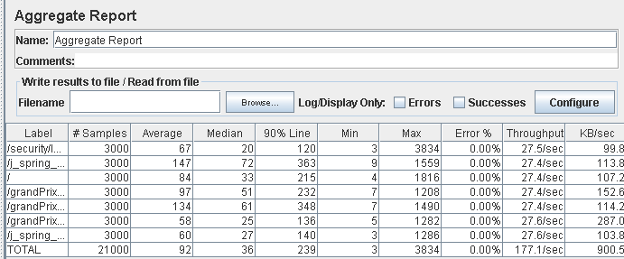

Performance thread results: 10,762 per minute

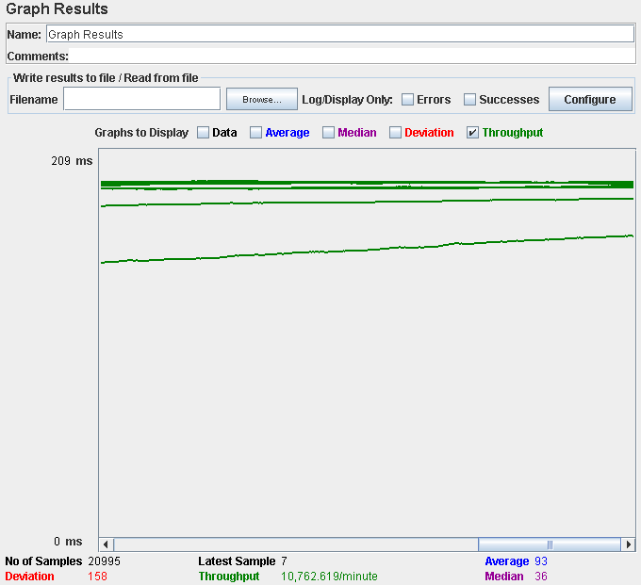

Computer performance:

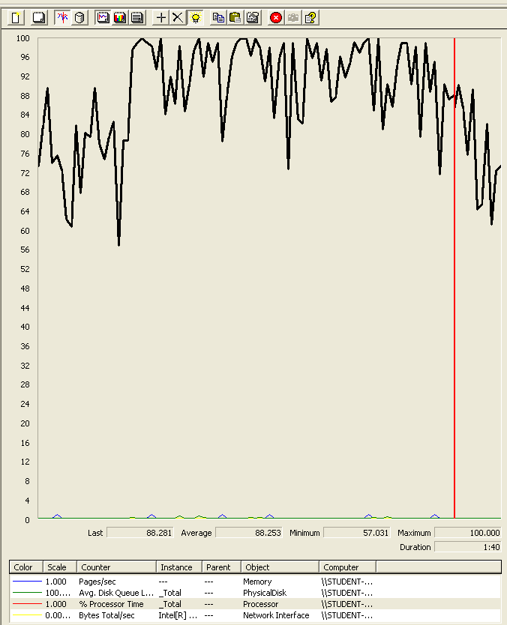

### Analysis results:

250 users and 10 loops: the application runs perfectly.

300 users and 10 loops: the application runs perfectly.

## Use case 26:

### As a team manager I want to manage my answers to the announcements

Number of Threads (users): 250

Ramp-Up Period (in seconds): 1

Loop count: 10

Performance test 90% results: Total 4756ms.

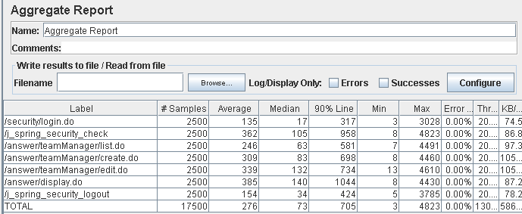

Performance thread results: 7,802 per minute

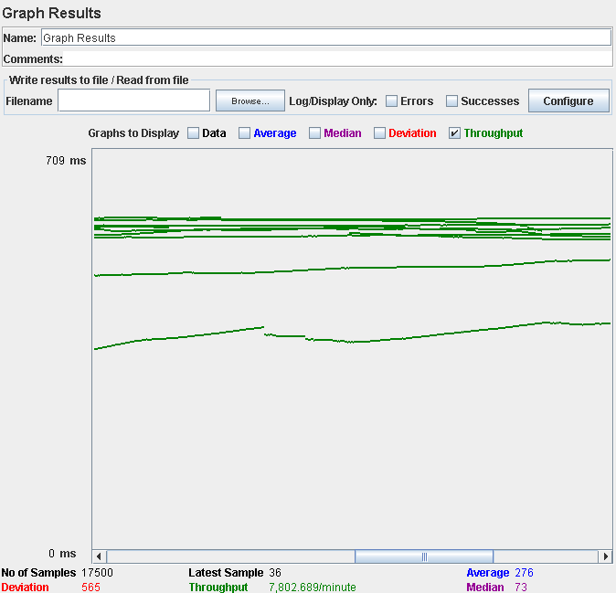

Number of Threads (users): 300

Ramp-Up Period (in seconds): 1

Loop count: 10

Performance test 90% results: Total 3,874ms.

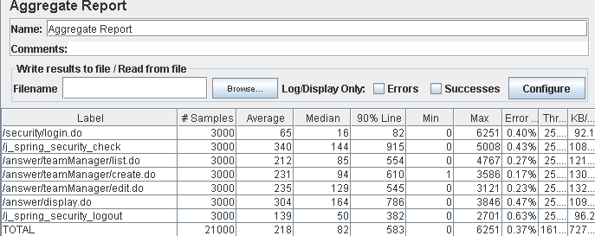

Performance thread results: 9,706 per minute

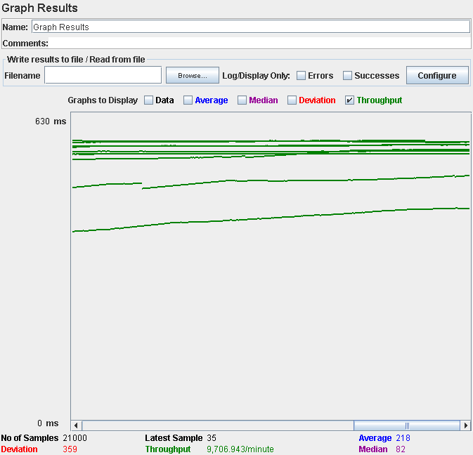

Computer performance:

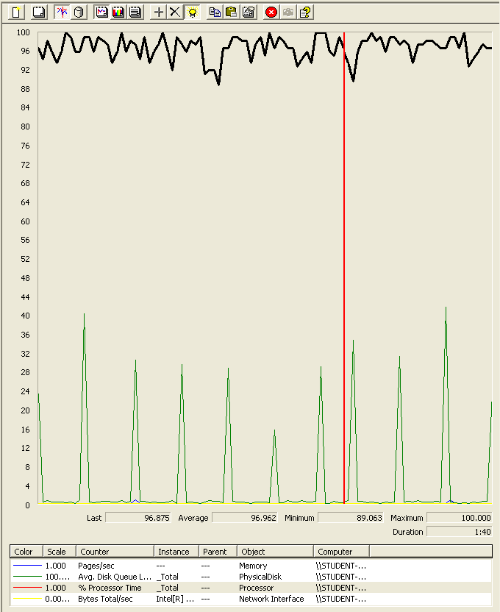

### Analysis results:

250 users and 10 loops: the application runs perfectly.

300 users and 10 loops: the application begins to have errors. We believe that it could be the processor.

## Use case 27:

### As an admin I want to manage the sectors of the circuits

Number of Threads (users): 200

Ramp-Up Period (in seconds): 1

Loop count: 10

Performance test 90% results: Total 13,009ms.

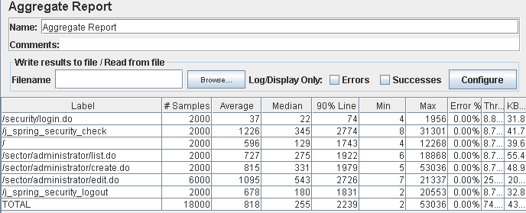

Performance thread results: 4,473 per minute

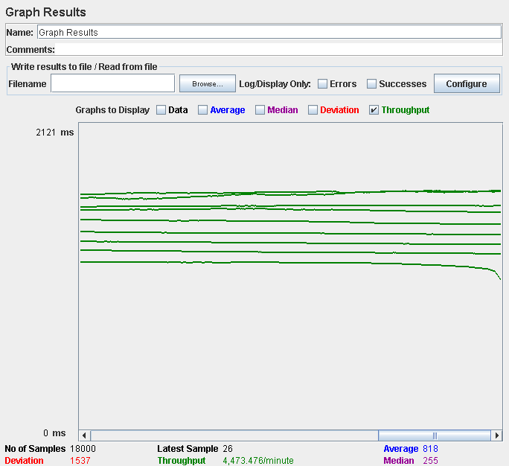

Number of Threads (users): 210

Ramp-Up Period (in seconds): 1

Loop count: 10

Performance test 90% results: Total 13,475ms

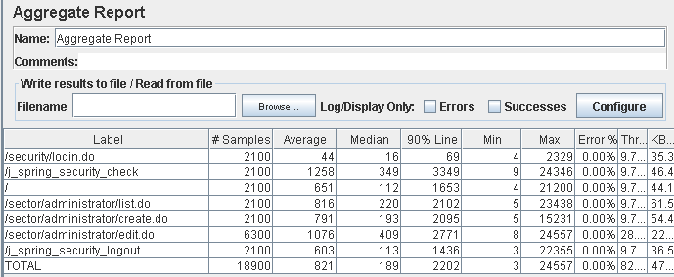

Performance thread results: 4,950 per minute

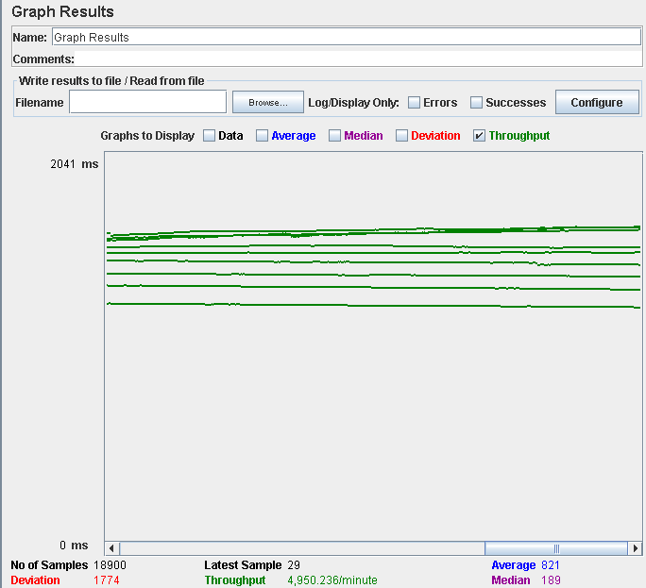

Computer performance:

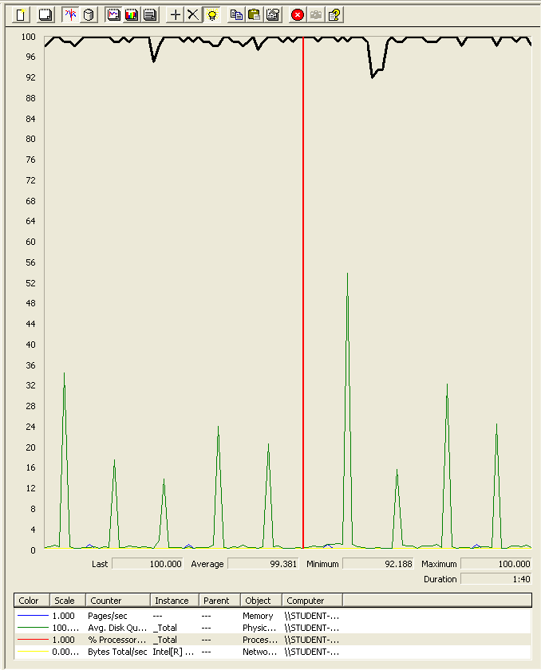

### Analysis results:

250 users and 10 loops: the application runs perfectly

300 users and 10 loops: the application doesn’t have errors, but the time completing the login surpass the 3 seconds limit.

## Use case 28:

### As a representative I want to manage my fan clubs

Number of Threads (users): 250

Ramp-Up Period (in seconds): 1

Loop count: 10

Performance test 90% results: Total 9,889ms

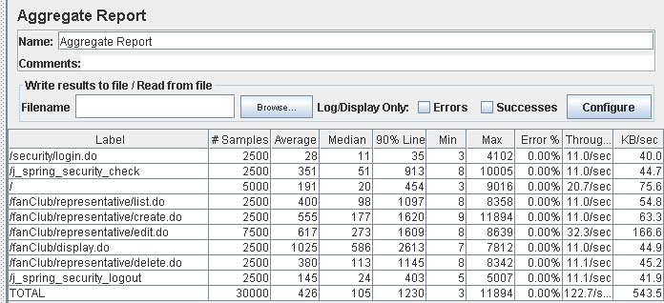

Performance thread results: 7,362 per minute

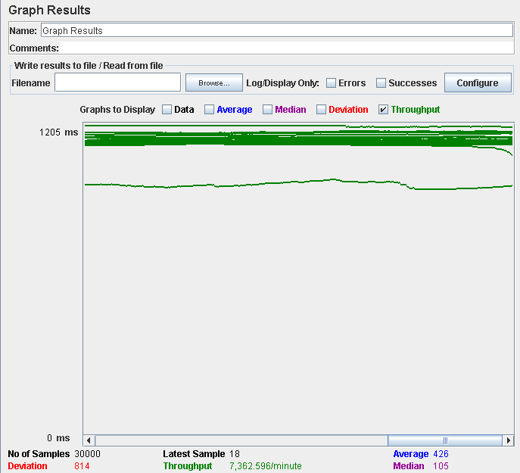

Number of Threads (users): 300

Ramp-Up Period (in seconds): 1

Loop count: 10

Performance test 90% results: Total 10,738ms

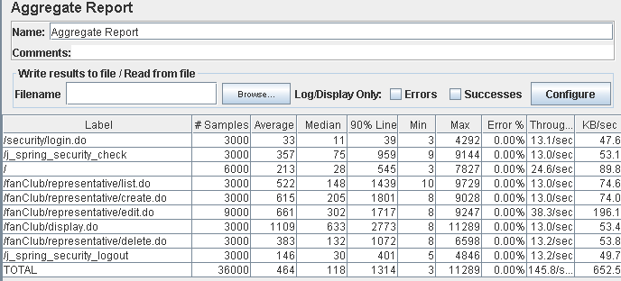

Performance thread results: 8,745 per minute

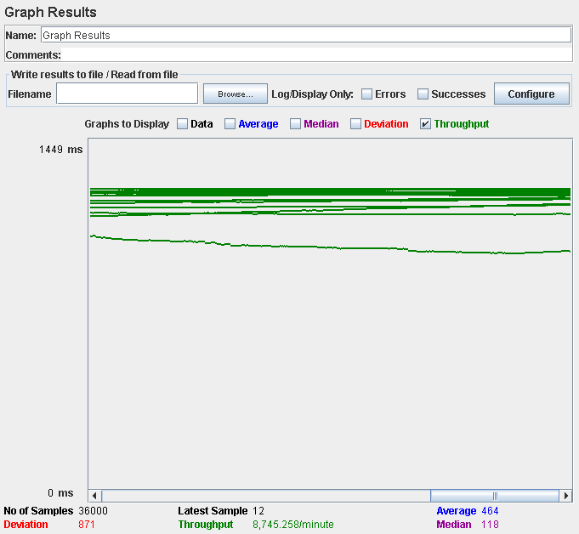

Computer performance:

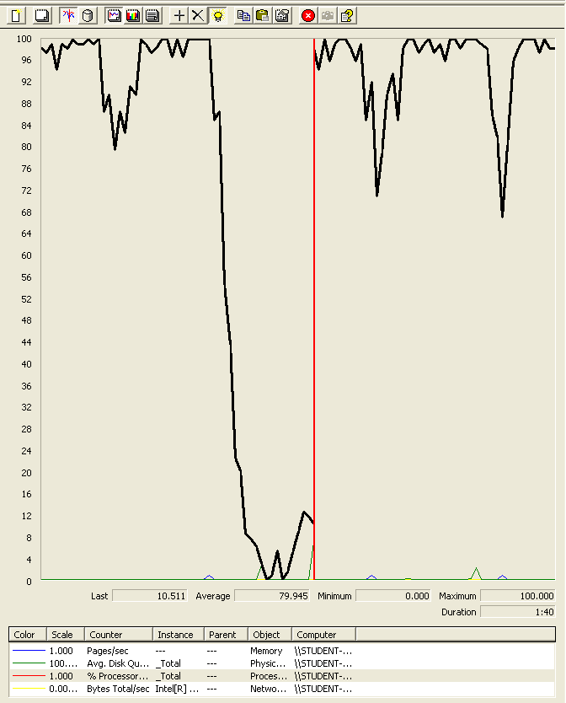

### Analysis results:

250 users and 10 loops: the application runs perfectly.

300 users and 10 loops: the application runs perfectly, the time spending displaying the fan clubs is near the limit.

## Use case 29:

### As a Rider I want to use a finder to filter the grand-prixes and navigate to them.

Number of Threads (users): 200

Ramp-Up Period (in seconds): 1

Loop count: 10

Performance test 90% results: Total 7,155ms.

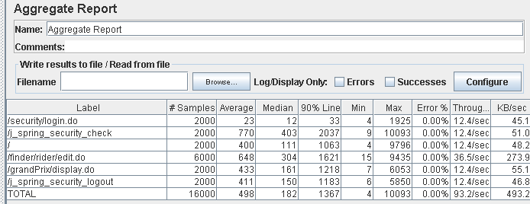

Performance thread results: 5,814 per minute

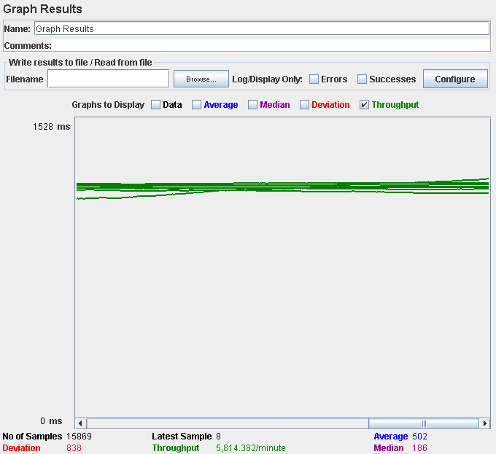

Number of Threads (users): 250

Ramp-Up Period (in seconds): 1

Loop count: 10

Performance test 90% results: Total 16,324ms

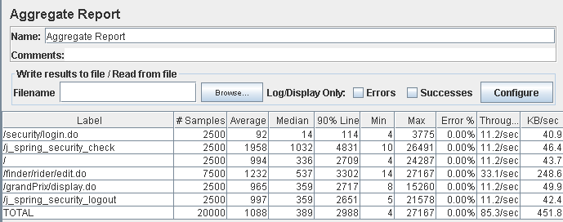

Performance thread results: 5,119 per minute

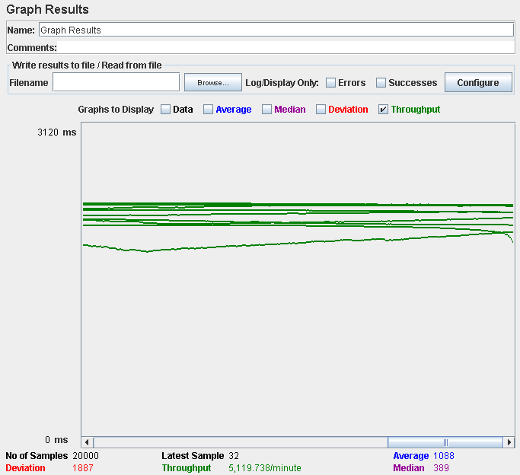

Computer performance:

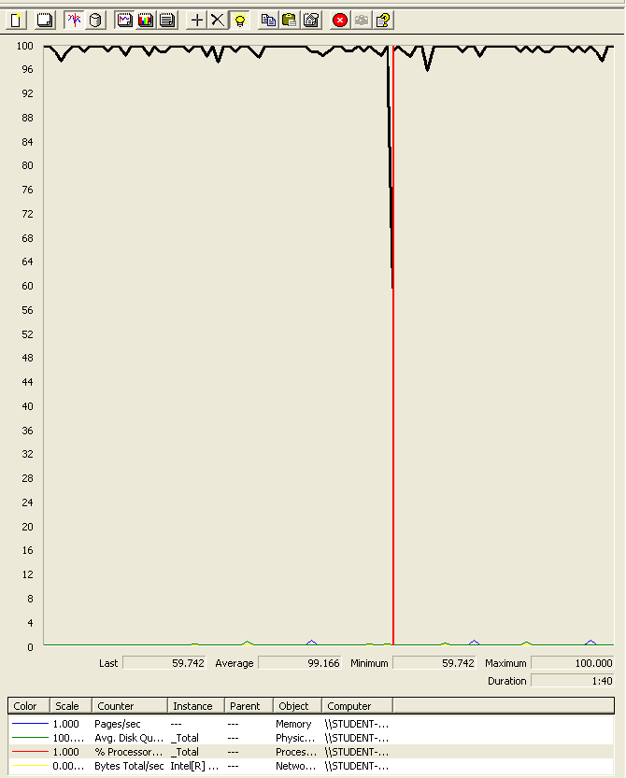

### Analysis results:

200 users and 10 loops: the application runs perfectly

250 users and 10 loops: the application doesn’t have errors but the time spend doing the actions is really high (near 5 secs for example). We believe is a processors bottleneck problem.

## Use case 30:

### As a race director I want to manage my applications and announcements

Number of Threads (users): 250

Ramp-Up Period (in seconds): 1

Loop count: 10

Performance test 90% results: Total 10,263.

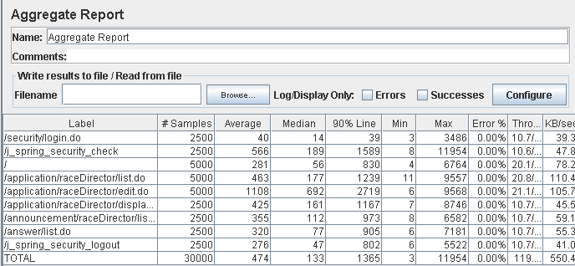

Performance thread results: 7,151 per minute

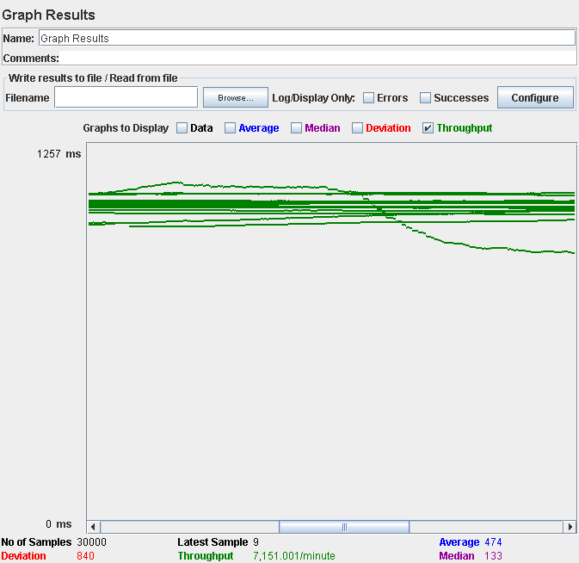

Number of Threads (users): 300

Ramp-Up Period (in seconds): 1

Loop count: 10

Performance test 90% results: Total 26,405ms

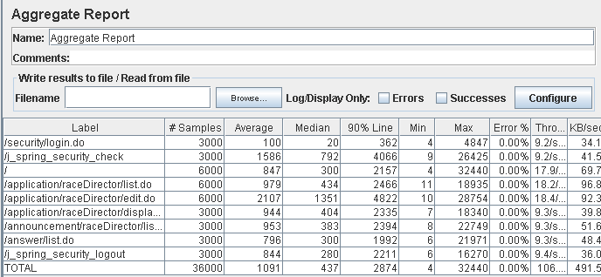

Performance thread results: 6,379 per minute

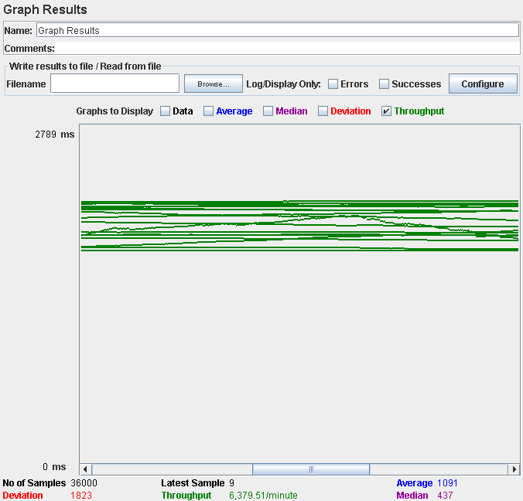

Computer performance:

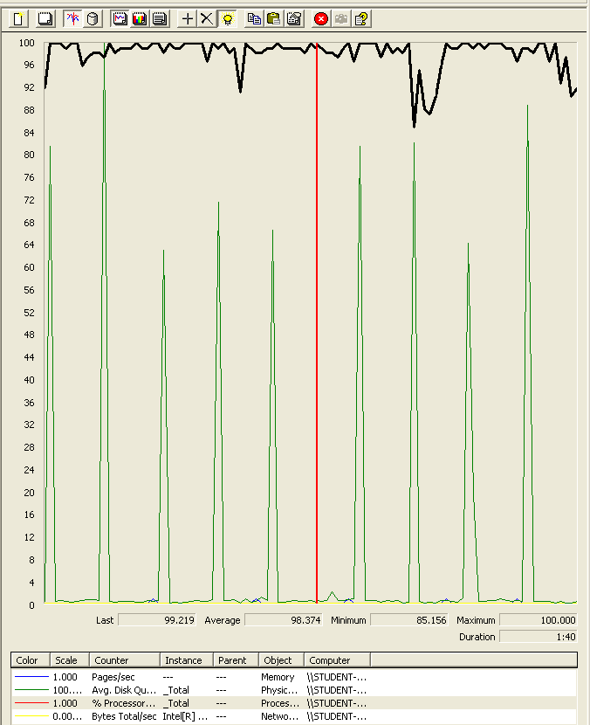

### Analysis results:

250 users and 10 loops: the application runs perfectly

300 users and 10 loops: the application doesn’t have errors but the time spend doing the actions is really high (near 5 secs for example). We believe is a processors bottleneck problem, the disk could be too.

## Use case 31:

### As a Race Director I want to create my circuits.

Number of Threads (users): 200

Ramp-Up Period (in seconds): 1

Loop count: 10

Performance test 90% results: Total 7,283ms.

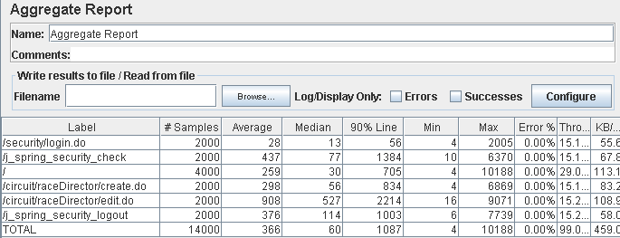

Performance thread results: 5,941 per minute

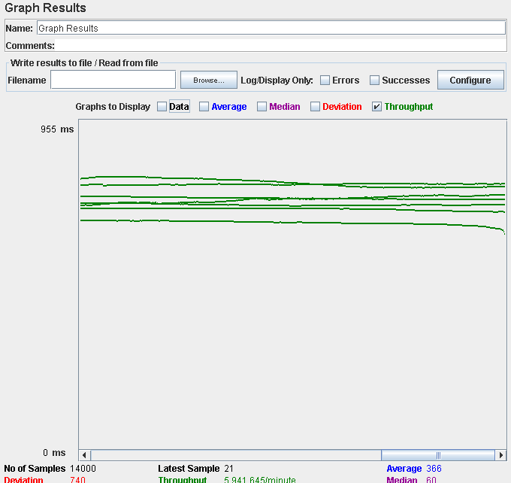

Number of Threads (users): 250

Ramp-Up Period (in seconds): 1

Loop count: 10

Performance test 90% results: Total 20,847ms.

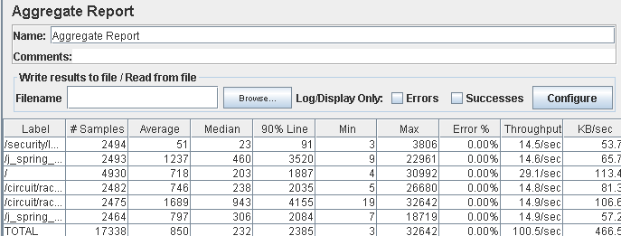

Performance thread results: 5,565 per minute

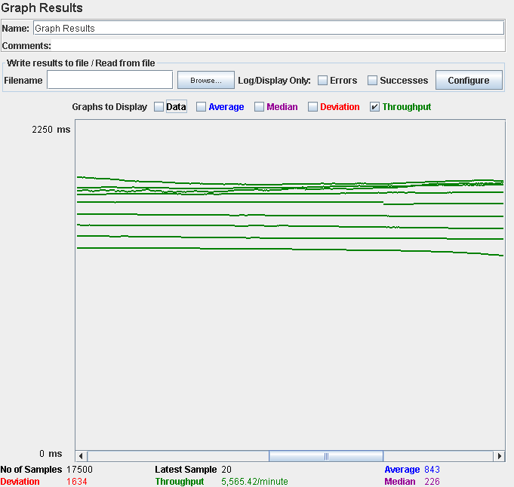

Computer performance:

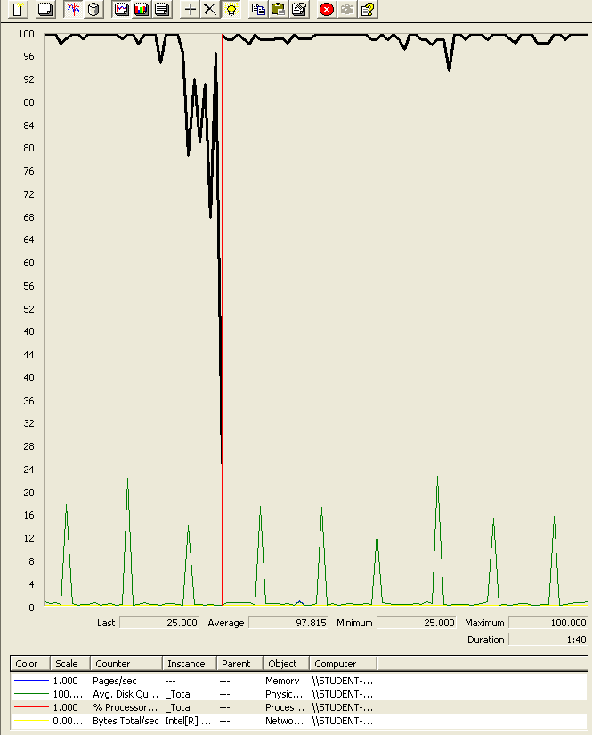

### Analysis results:

200 users and 10 loops: the application runs perfectly

250 users and 10 loops: the application doesn’t have errors but the time spend doing the actions is really high (near 5 secs for example). We believe is a processors bottleneck problem.

## Use case 32:

### As a Race Director I want to list, display and delete my circuits

Number of Threads (users): 250

Ramp-Up Period (in seconds): 1

Loop count: 10

Performance test 90% results: Total 489ms.

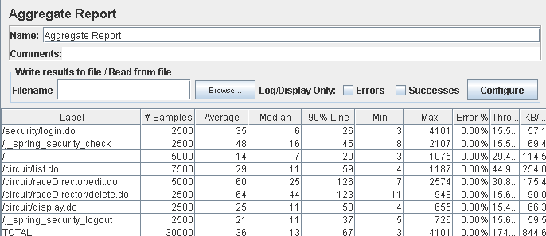

Performance thread results: 10,441 per minute

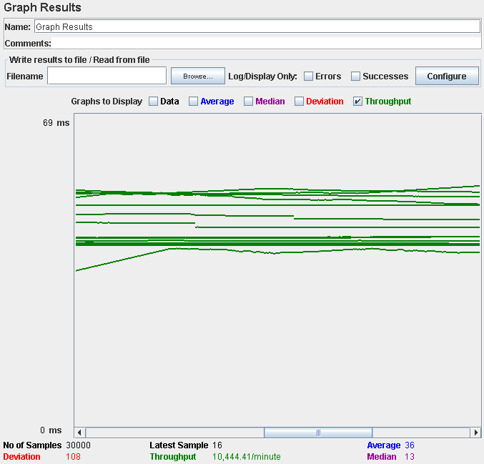

Number of Threads (users): 300

Ramp-Up Period (in seconds): 1

Loop count: 10

Performance test 90% results: Total 1,063ms.

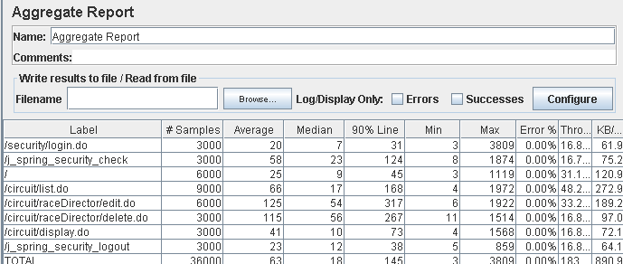

Performance thread results: 11,012 per minute

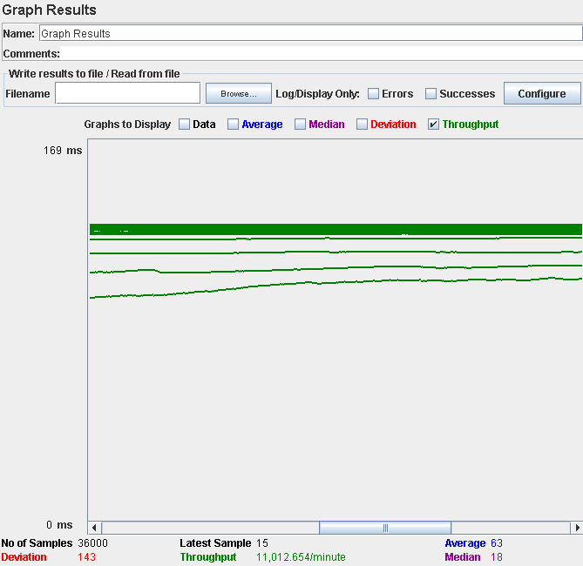

Computer performance:

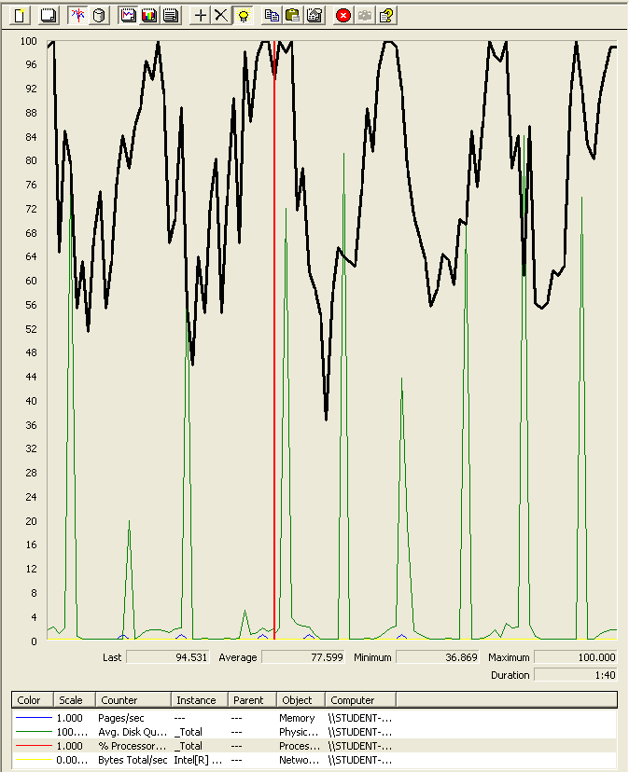

### Analysis results:

250 users and 10 loops: the application runs perfectly

300 users and 10 loops: the application runs perfectly

## Use case 33:

### As a representative I want to manage my meetings.

Number of Threads (users): 200

Ramp-Up Period (in seconds): 1

Loop count: 10

Performance test 90% results: Total 12,668ms.

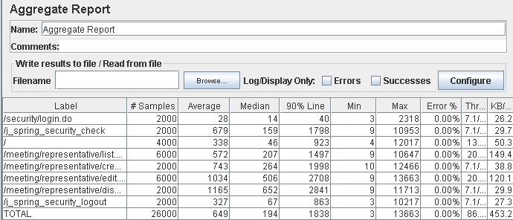

Performance thread results: 5,196 per minute

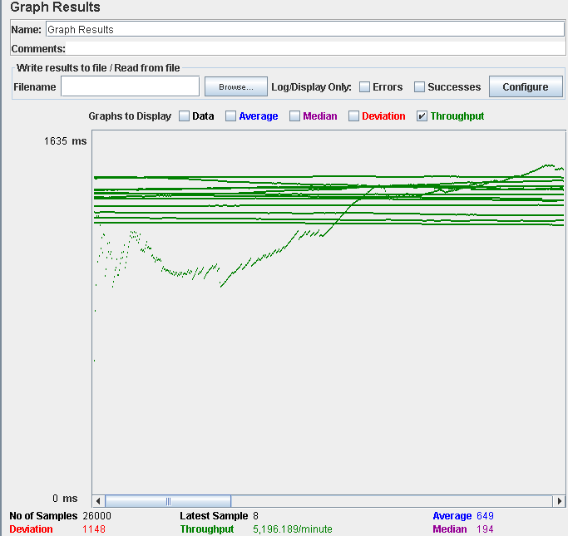

Number of Threads (users): 225

Ramp-Up Period (in seconds): 1

Loop count: 10

Performance test 90% results: Total 40,723ms.

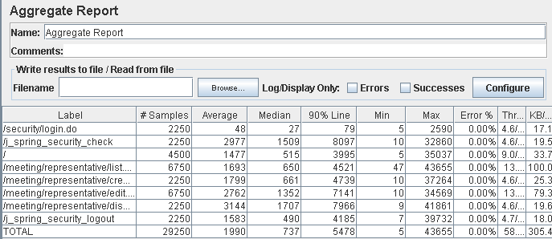

Performance thread results: 3,487 per minute

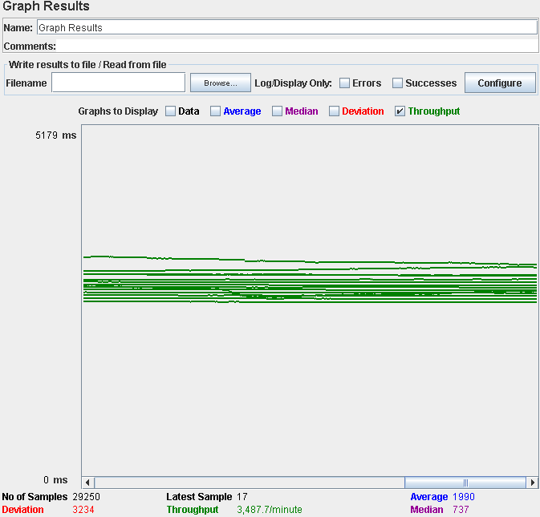

Computer performance:

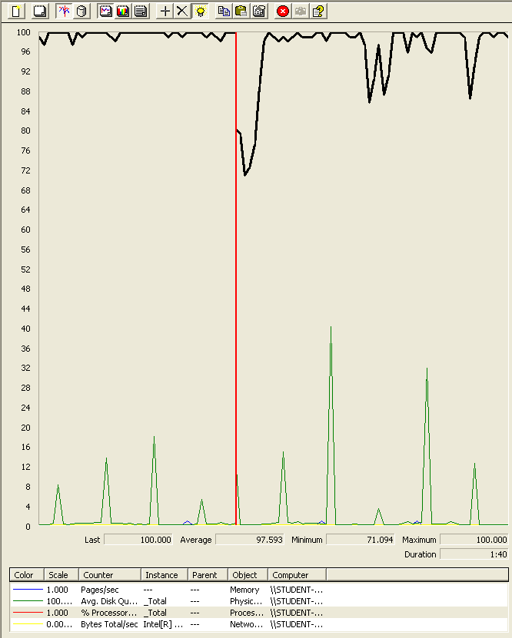

### Analysis results:

200 users and 10 loops: the application runs perfectly

225 users and 10 loops: the application doesn’t have errors but the time spend doing the actions is really high (near 5 secs for example). We believe is a processors bottleneck problem.

## Use case 34:

### As a team manager I want to manage my team.

Number of Threads (users): 200

Ramp-Up Period (in seconds): 1

Loop count: 10

Performance test 90% results: Total 793ms.

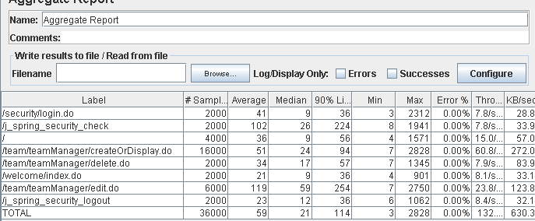

Performance thread results: 7,953 per minute

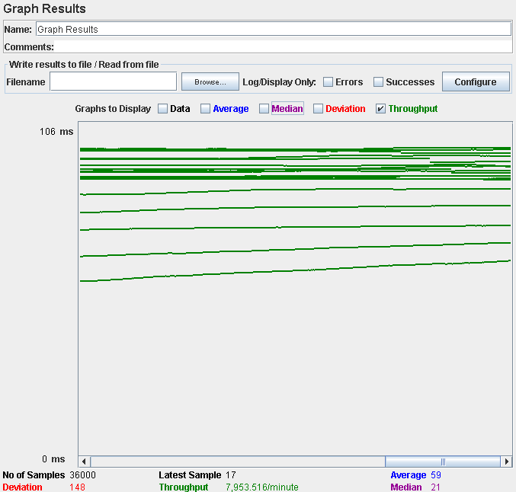

Number of Threads (users): 300

Ramp-Up Period (in seconds): 1

Loop count: 10

Performance test 90% results: Total 16,716ms.

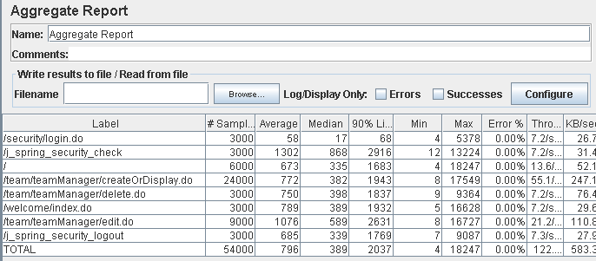

Performance thread results: 7,346 per minute

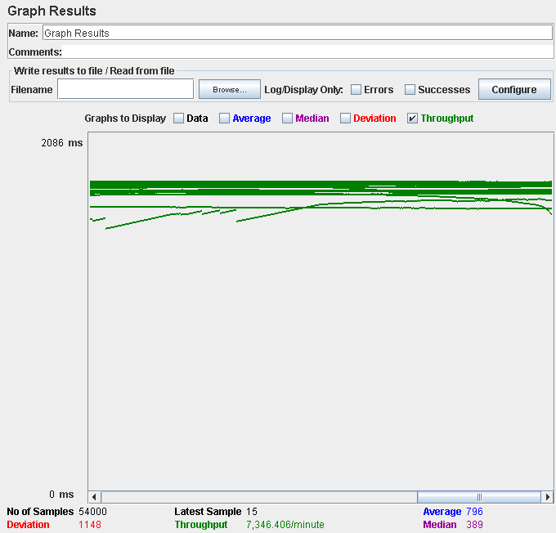

Computer performance:

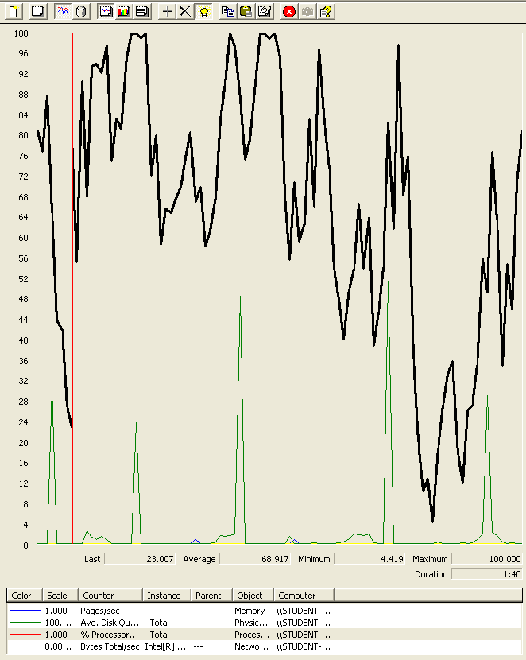

### Analysis results:

200 users and 10 loops: the application runs perfectly

250 users and 10 loops: the application doesn’t have errors but the time spend doing login action is near the limit of 3 seconds. We believe is a processors bottleneck problem.

## Use case 35:

### As a team manager I want to sign riders to my team.

Number of Threads (users): 250

Ramp-Up Period (in seconds): 1

Loop count: 10

Performance test 90% results: Total 600ms.

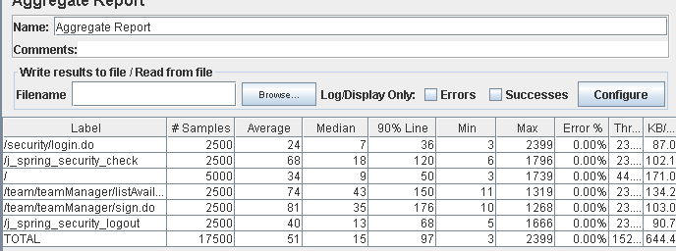

Performance thread results: 9,164 per minute

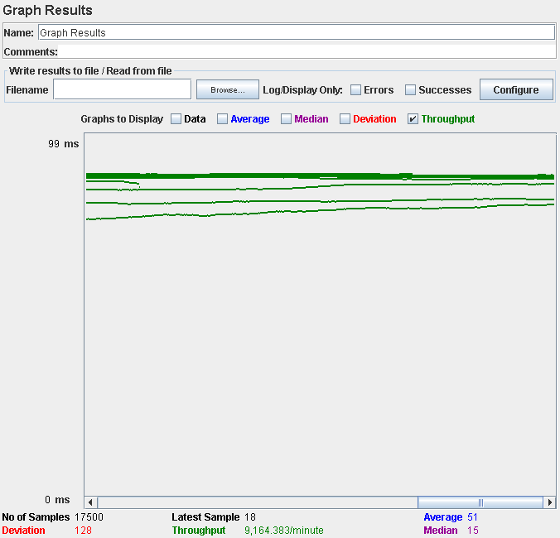

Number of Threads (users): 300

Ramp-Up Period (in seconds): 1

Loop count: 10

Performance test 90% results: Total 2,220ms.

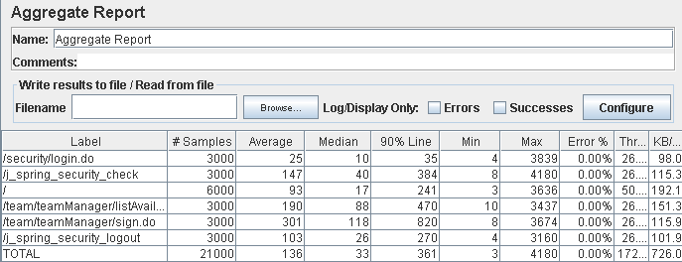

Performance thread results: 10,318 per minute

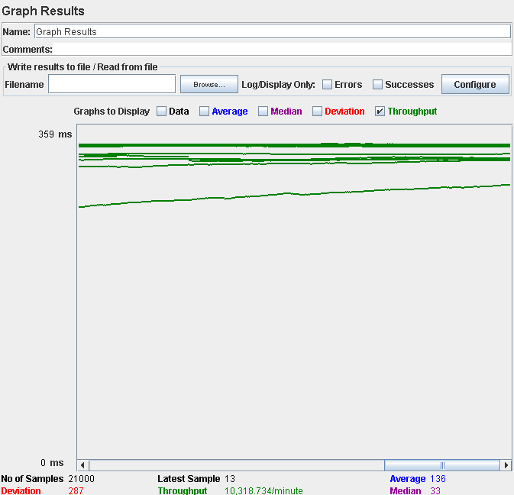

Computer performance:

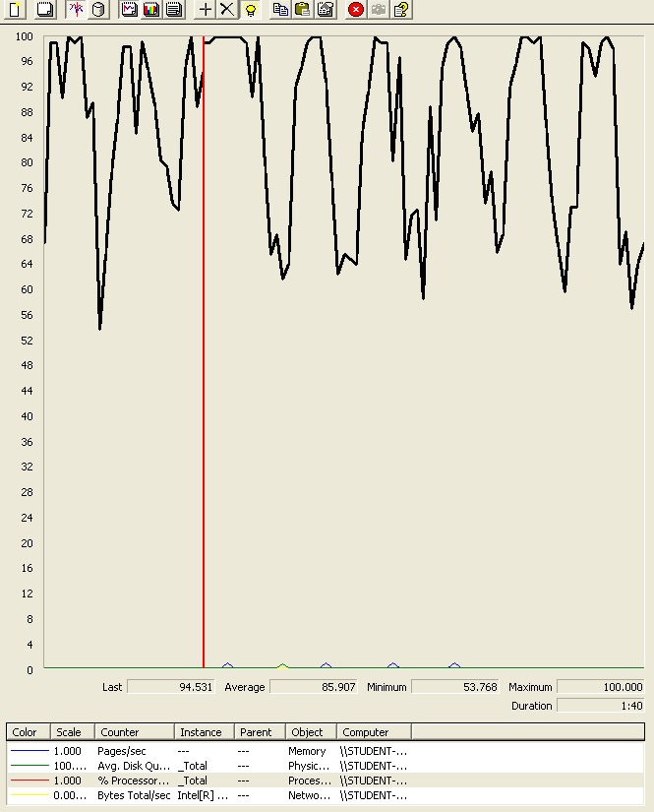

### Analysis results:

250 users and 10 loops: the application runs perfectly

250 users and 10 loops: the application runs perfectly

## Use case 36:

### As a rider I want to see the world championships, grand prixes, circuits, races, forecasts and my team.

Number of Threads (users): 250

Ramp-Up Period (in seconds): 1

Loop count: 10

Performance test 90% results: Total 424ms.

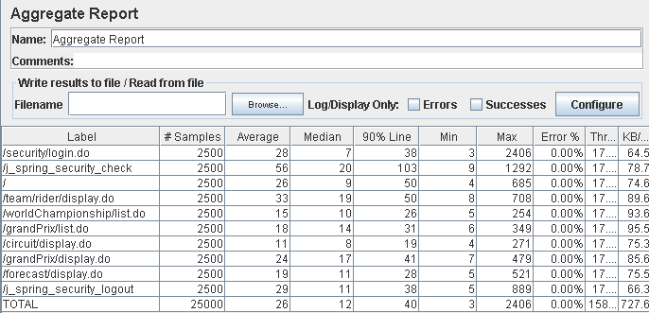

Performance thread results: 9,518 per minute

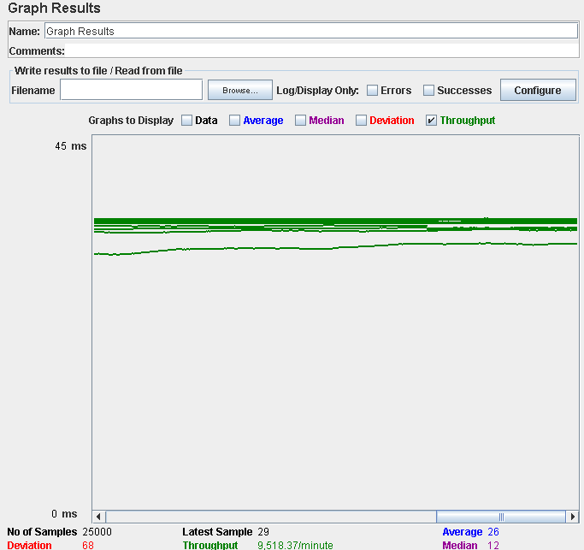

Number of Threads (users): 300

Ramp-Up Period (in seconds): 1

Loop count: 10

Performance test 90% results: Total 19,863

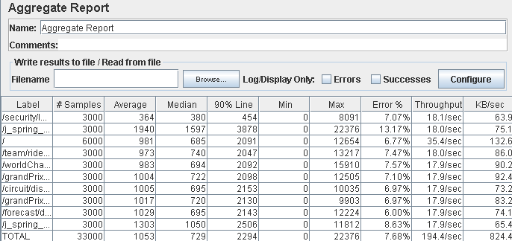

Performance thread results: 11,664 per minute

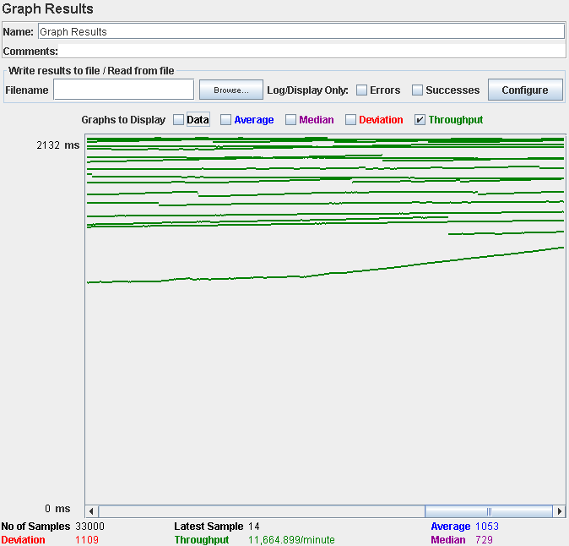

Computer performance:

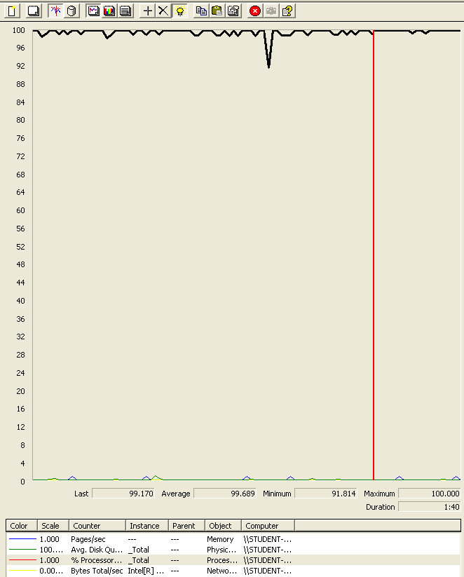

### Analysis results:

200 users and 10 loops: the application runs perfectly

250 users and 10 loops: the application have errors and the time spend doing login action is high. We believe is a processors bottleneck problem.

## Use case 37:

### As a rider I want to manage my meetings.

Number of Threads (users): 200

Ramp-Up Period (in seconds): 1

Loop count: 10

Performance test 90% results: Total 12,967.

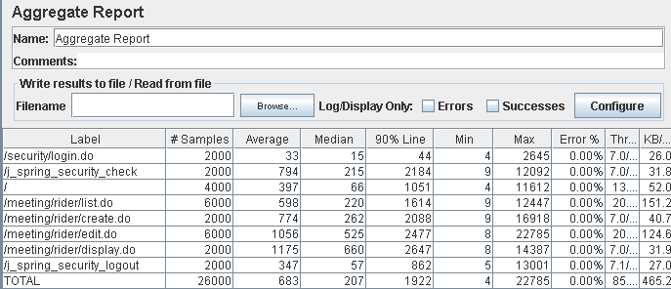

Performance thread results: 5,143 per minute

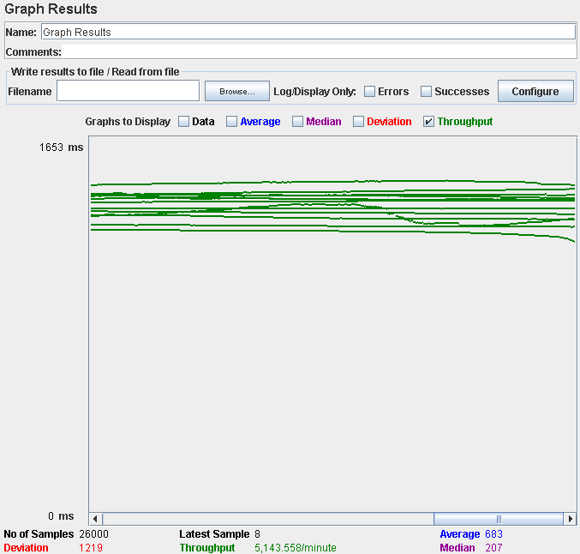

Number of Threads (users): 250

Ramp-Up Period (in seconds): 1

Loop count: 10

Performance test 90% results: Total 43,401ms.

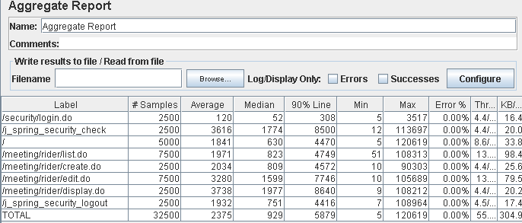

Performance thread results: 3,352 per minute

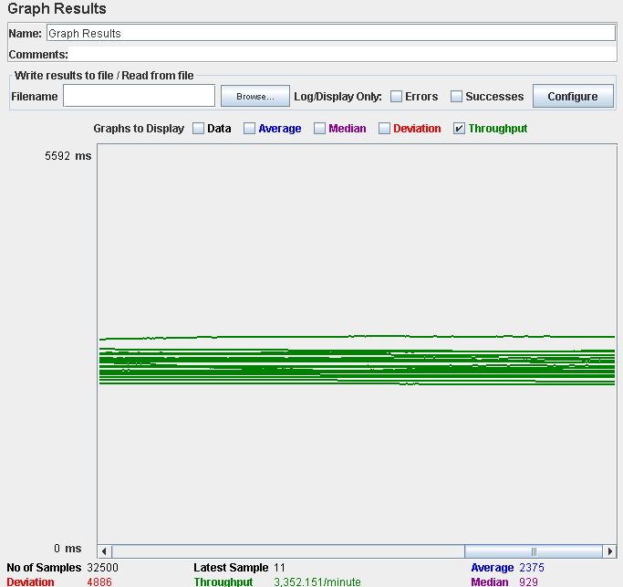

Computer performance:

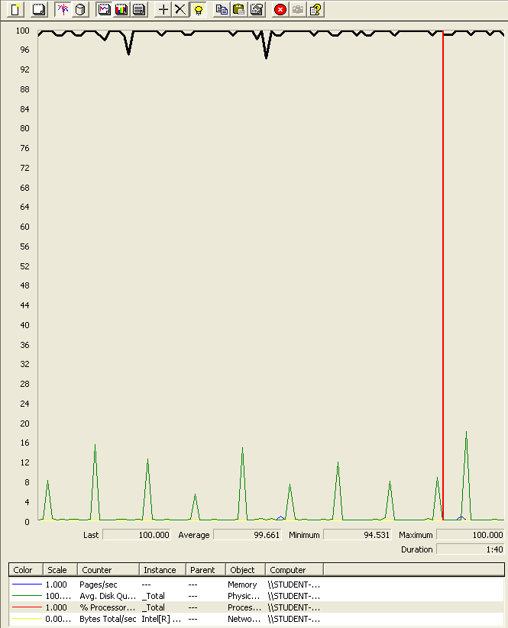

### Analysis results:

200 users and 10 loops: the application runs perfectly

250 users and 10 loops: the application doesn’t have errors but the time spend completing the actions is too high. We believe is a processors bottleneck problem.

## Use case 38:

### As a sponsor I want to create sponsorships.

Number of Threads (users): 200

Ramp-Up Period (in seconds): 1

Loop count: 10

Performance test 90% results: Total 8,156ms.

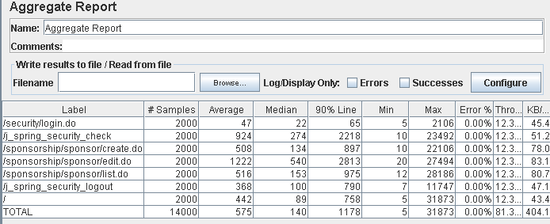

Performance thread results: 4,876 per minute

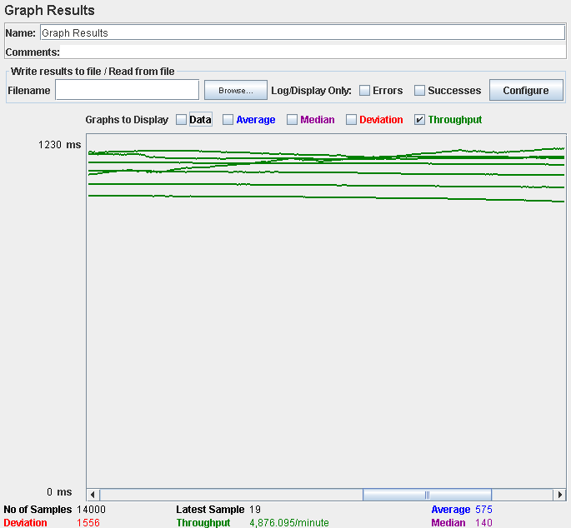

Number of Threads (users): 300

Ramp-Up Period (in seconds): 1

Loop count: 10

Performance test 90% results: Total 46,166ms.

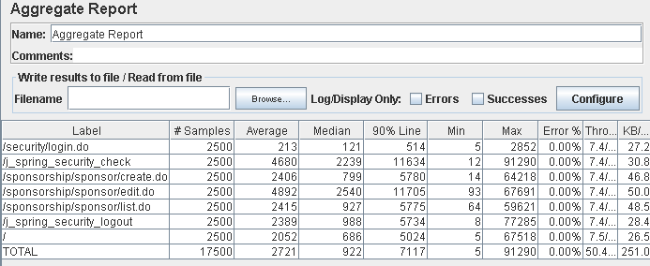

Performance thread results: 3.021 per minute

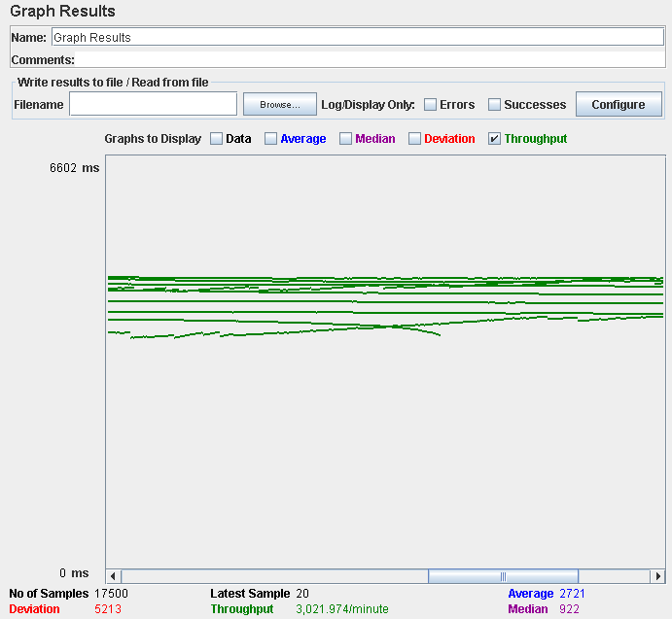

Computer performance:

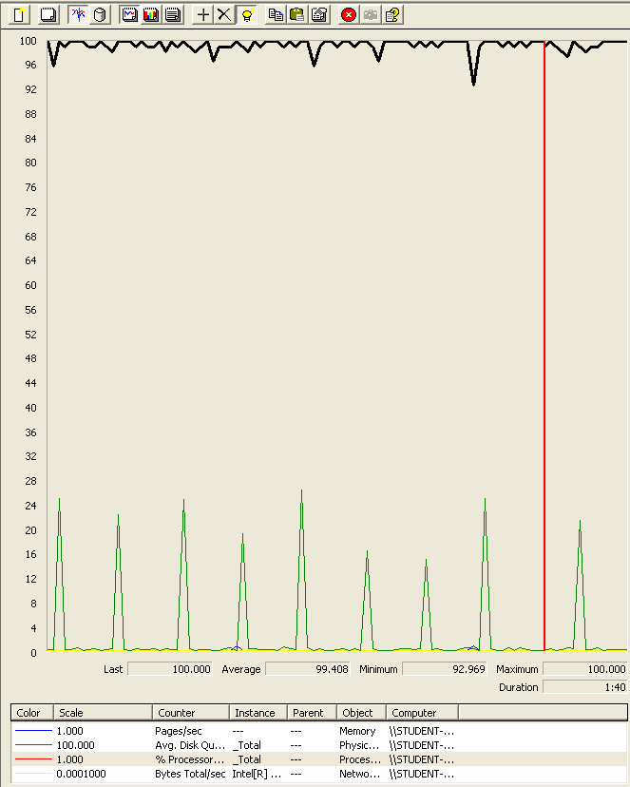

### Analysis results:

200 users and 10 loops: the application runs perfectly, but the time spend creating the sponsorship is near the limit of 3 secs.

250 users and 10 loops: the application runs without errors but the times are incredibly high. We believe is a processor bottleneck problem.

## Use case 39:

### As a sponsor I want to see and update my sponsorships.

Number of Threads (users): 200

Ramp-Up Period (in seconds): 1

Loop count: 10

Performance test 90% results: Total 2,125ms.

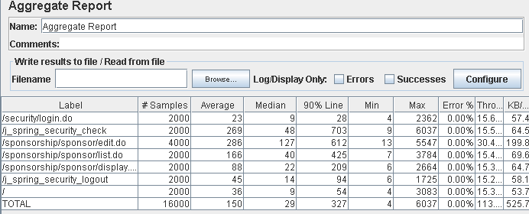

Performance thread results: 6,804 per minute

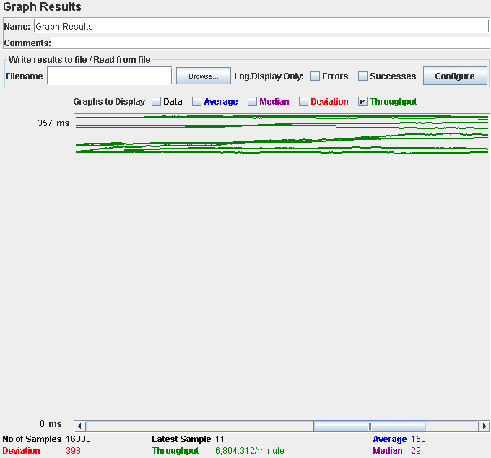

Number of Threads (users): 300

Ramp-Up Period (in seconds): 1

Loop count: 10

Performance test 90% results: Total 3,173ms.

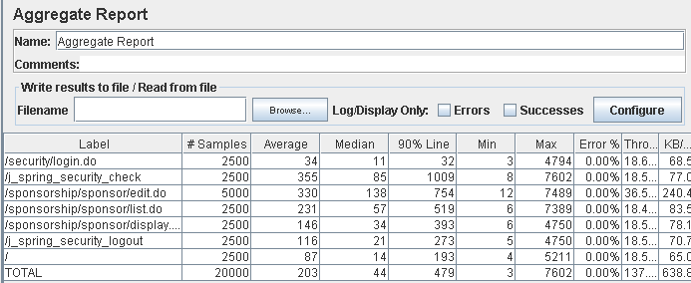

Performance thread results: 8,262 per minute

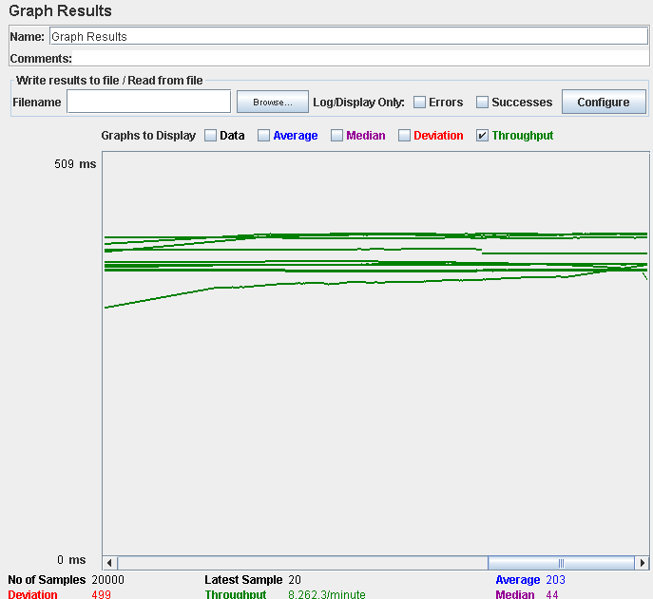

Computer performance:

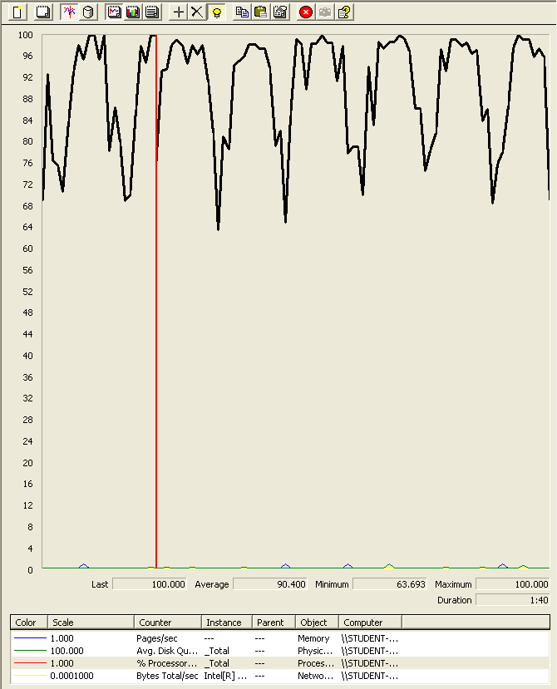

### Analysis results:

200 users and 10 loops: the application runs perfectly

250 users and 10 loops: the application runs perfectly

## Use case 40:

### As an admin I want to launch a process to compute the score of every representative and rider, edit the list of the positive and negative words used to compute the score and display a dashboard with information of the system:

Number of Threads (users): 250

Ramp-Up Period (in seconds): 1

Loop count: 10

Performance test 90% results: Total 4,756ms.



Performance thread results: 7.802 per minute



Number of Threads (users): 300

Ramp-Up Period (in seconds): 1

Loop count: 10

Performance test 90% results: Total 3,784ms.



Performance thread results: 9,706 per minute



Computer performance:

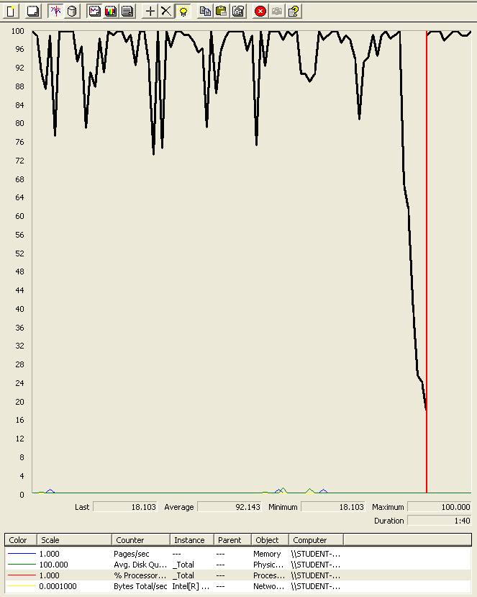

### Analysis results:

250 users and 10 loops: the application runs perfectly

300 users and 10 loops: the application begin to have errors. We believe is a processor bottleneck problem.

## Use case 41:

### As a sponsor I want to see the teams of the systems.

Number of Threads (users): 250

Ramp-Up Period (in seconds): 1

Loop count: 10

Performance test 90% results: Total 4,907ms.

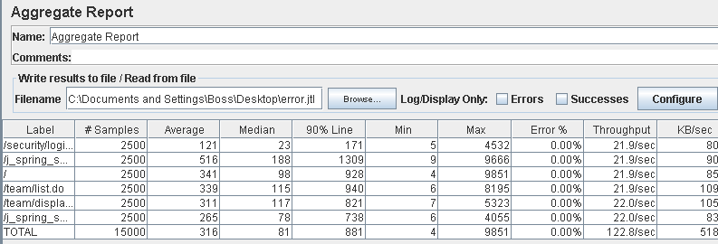

Performance thread results: 7,369 per minute

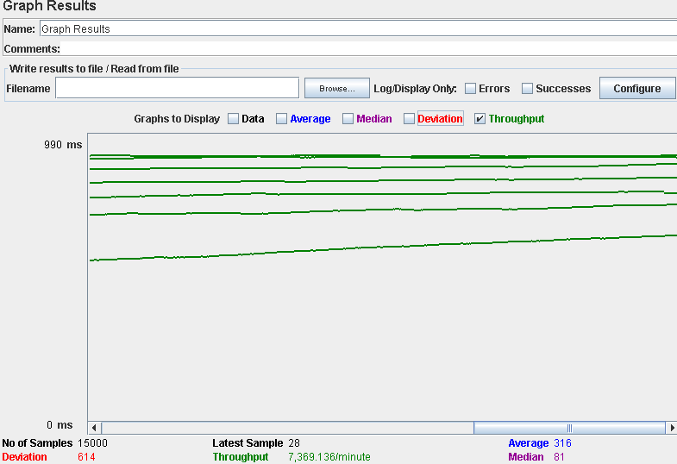

Number of Threads (users): 300

Ramp-Up Period (in seconds): 1

Loop count: 10

Performance test 90% results: Total 4,738ms.

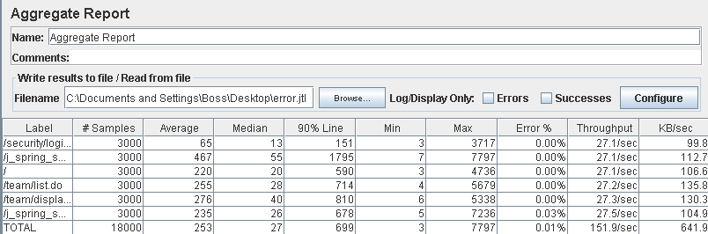

Performance thread results: 9,112 per minute

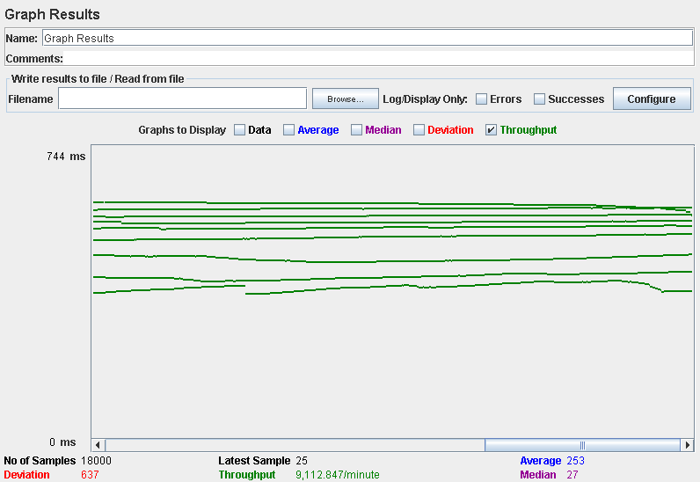

Computer performance:

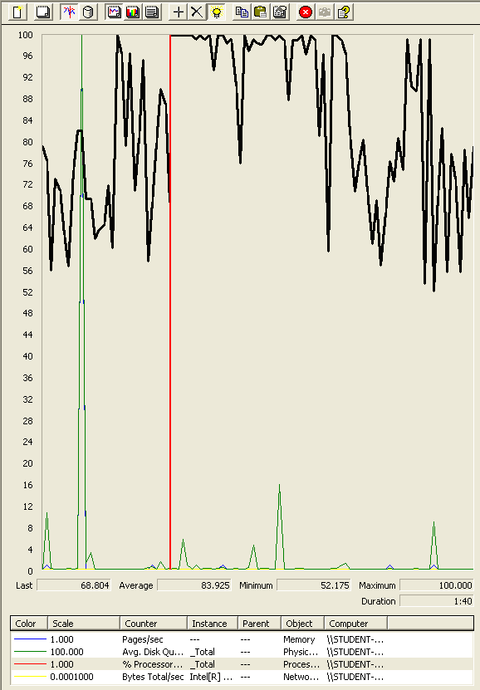

### Analysis results:

250 users and 10 loops: the application runs perfectly

300 users and 10 loops: the application begin to have errors. We believe is a processor bottleneck problem and the disk made a unusual behavior.

## Use case 42:

### As an authenticated user I want update and delete message boxes.

Number of Threads (users): 250

Ramp-Up Period (in seconds): 1

Loop count: 10

Performance test 90% results: Total 11,245ms

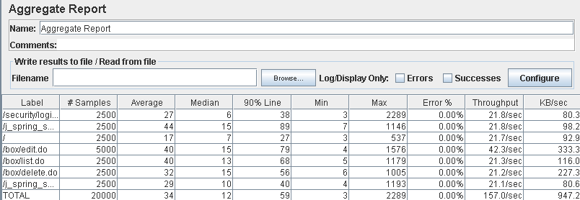

Performance thread results: 6,651 per minute

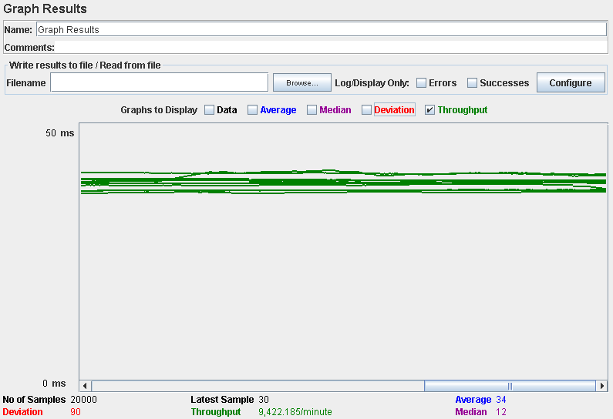

Number of Threads (users): 300

Ramp-Up Period (in seconds): 1

Loop count: 10

Performance test 90% results: Total 12,257ms.

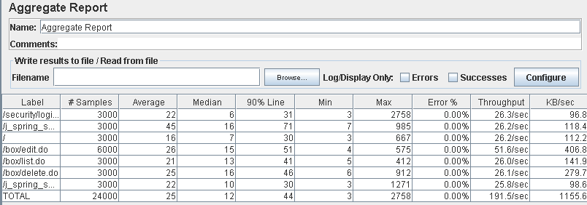

Performance thread results: 6,419 per minute

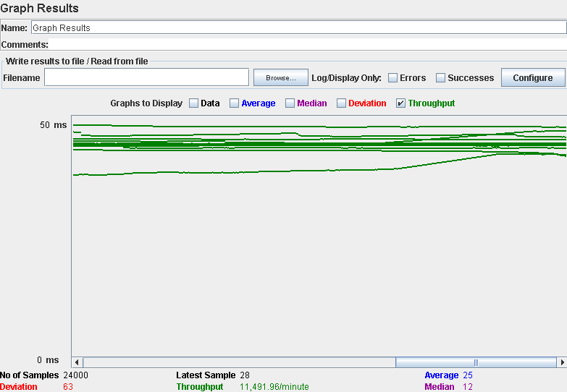

Computer performance:

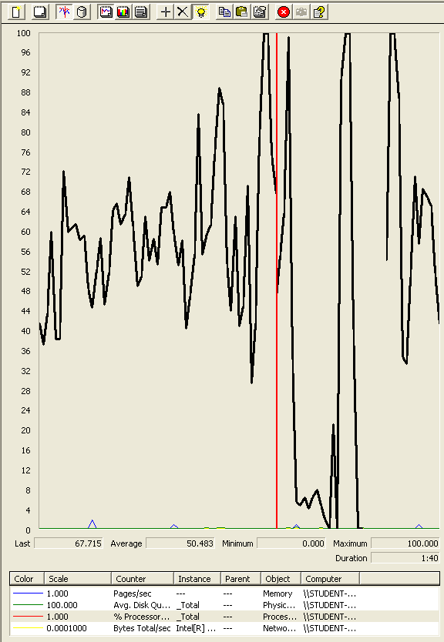

### Analysis results:

250 users and 10 loops: the application runs perfectly

300 users and 10 loops: the application runs perfectly

# Conclussion:

After the analysis of all the test realized, we can say that for 200 users and 10 loops all of our tests were successful, without any errors or excessive answer time, but some of the test had some actions near 3 seconds (between 2,500 ms and 2,800 ms).

It seems that from 210 users the time the user spend waiting for the server to respond could be higher than 3 seconds, and from 250 users the system could have server errors.

Since some of the test with 200 users had actions that were near 3 seconds, to avoid this, we believe that with 180/190 users, a bit less than the 200 that we used to prove the tests, the system will answer correctly without errors or excessive answers times that could affect the user experience.

Changing the processor for a better one with more cores could mean an improvement in the number of concurrent users and after this change maybe a disk with better specs would be the way to go to continue increasing the allowed users.